UAT Evidence:

Landing page:   
  
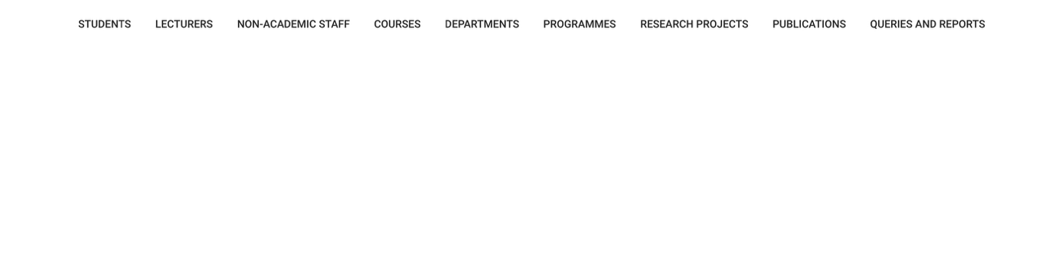

Students landing page:   
  
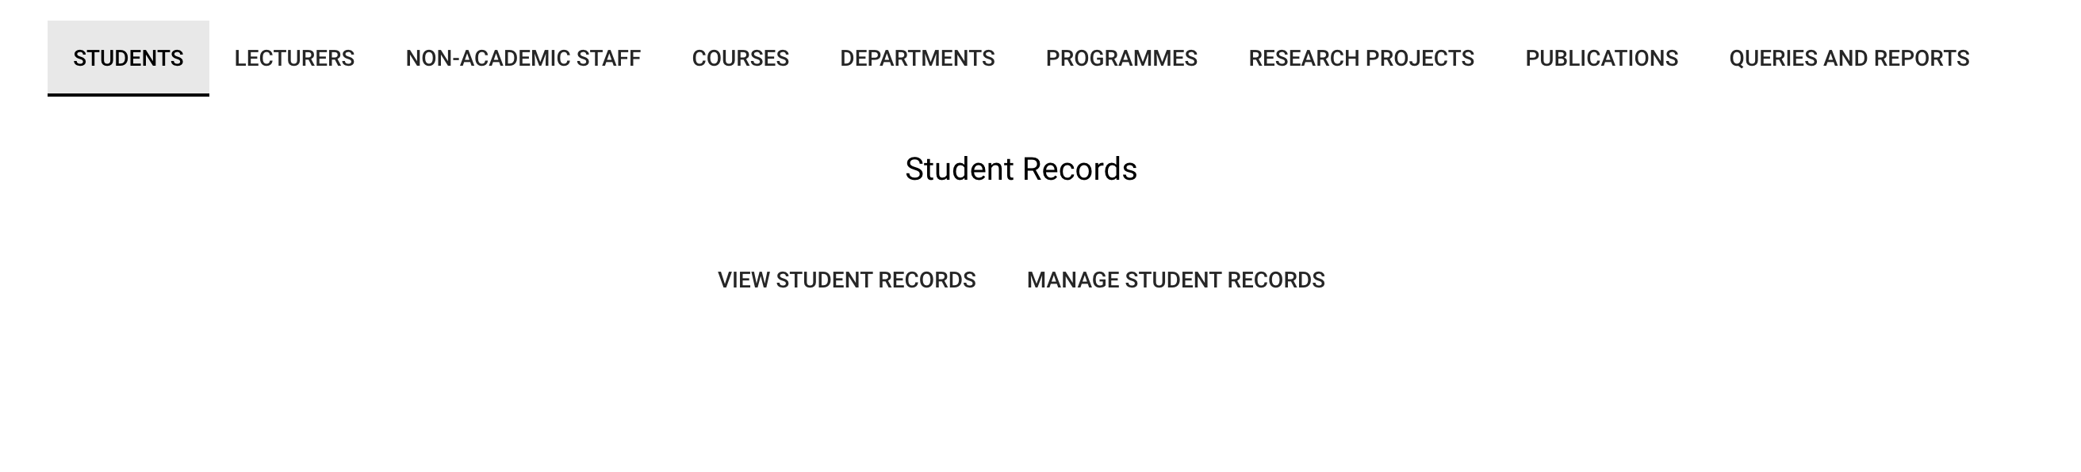

**UAT Evidence:**

**View Student records:**

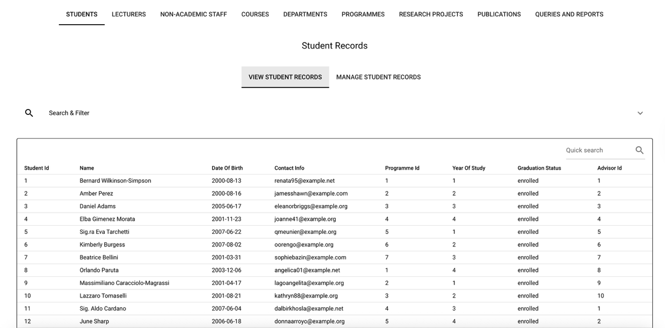

**Search & Filter:**

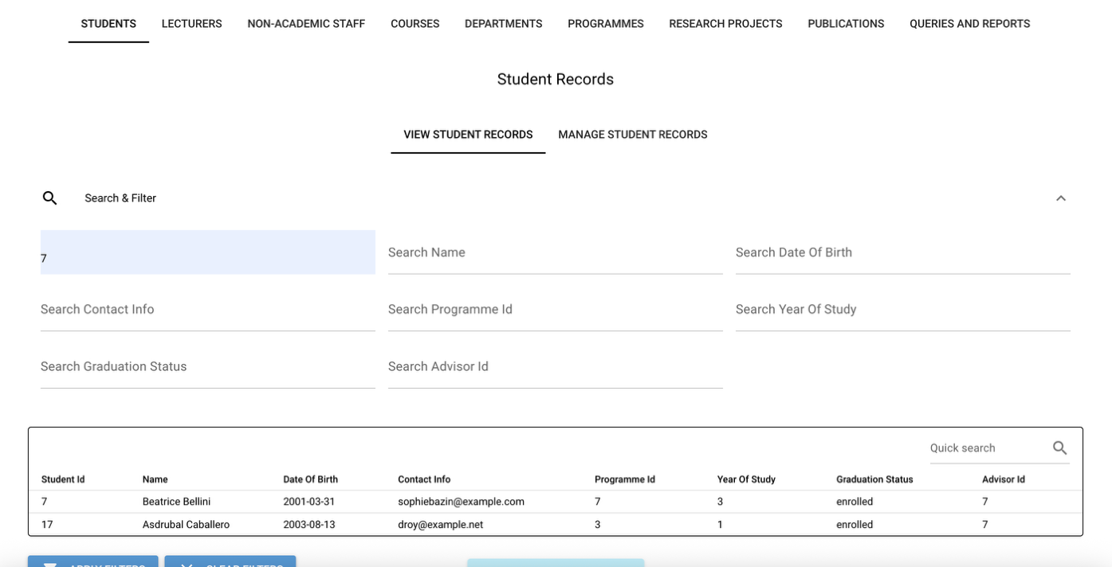

**Manage Student Records:**

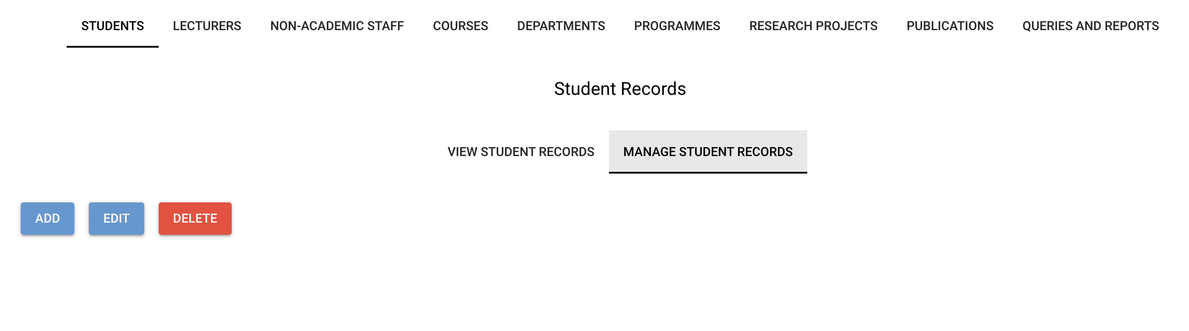

**Add Student:**

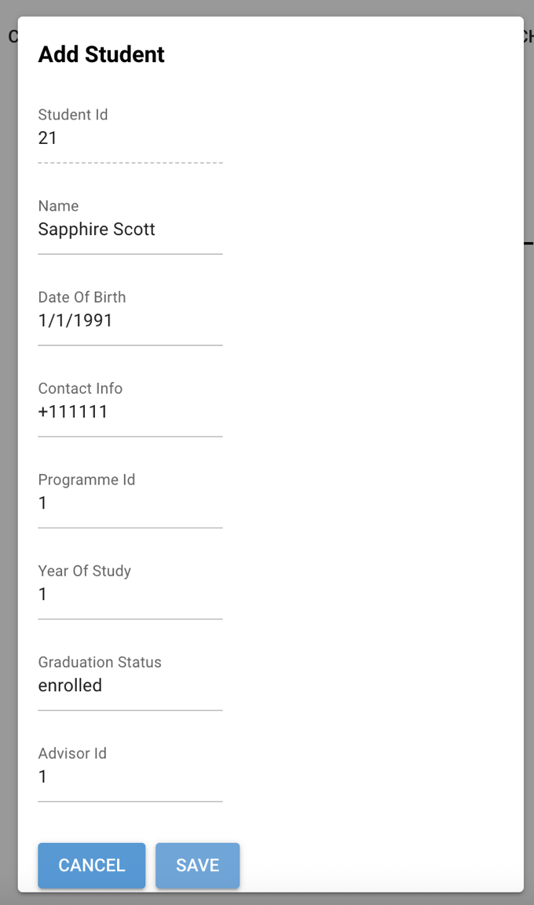

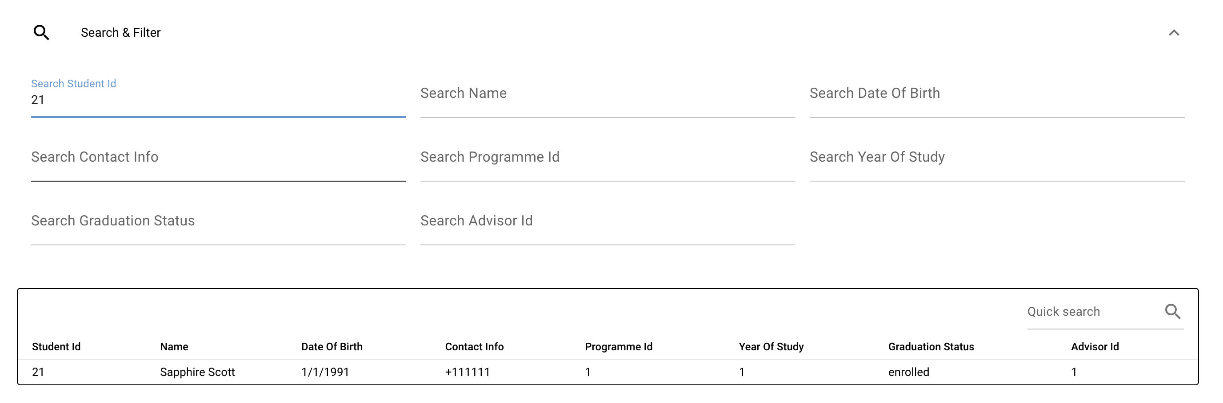

**Result:** Pass (with known limitation on foreign key validation)

**Edit Student:**

**User Acceptance Testing - Known Limitation**

During testing of the Edit Student functionality, an integrity constraint error was encountered when attempting to assign a student to a non-existent Programme or Advisor.

This behaviour is expected and confirms that foreign key constraints are correctly enforced at the database level. However, the GUI currently allows free-text entry for foreign key fields, which can result in invalid references being submitted.

**Impact:**

* Prevents invalid data from being persisted
* Error surfaced at runtime rather than prevented at input stage

**Proposed Enhancement:**

* Replace free-text inputs with dropdown selections populated from valid Programme and Lecturer IDs
* Add client-side validation prior to submission to improve user experience

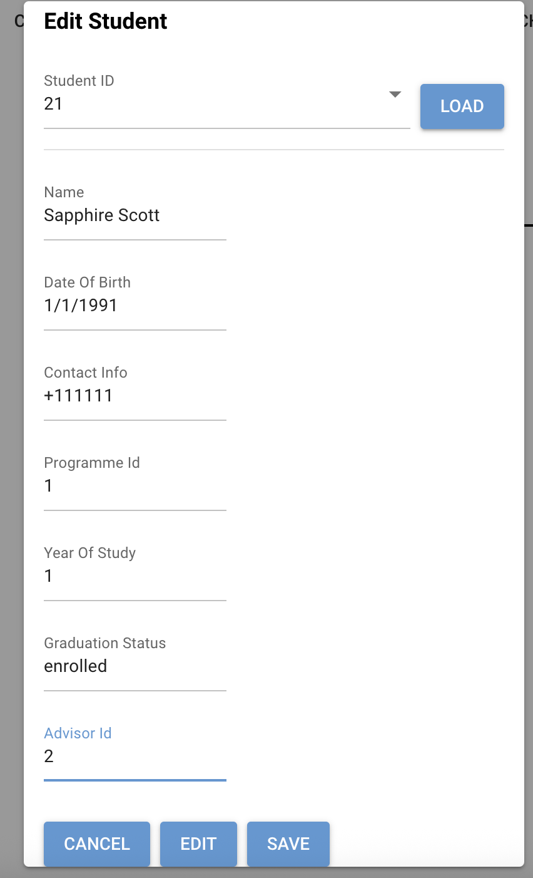

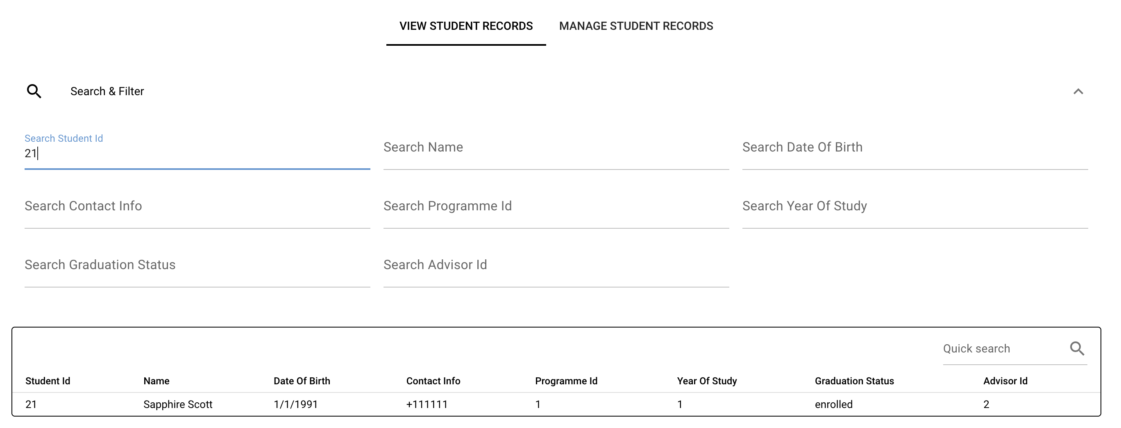

**Result:** Pass (with known limitation on foreign key validation)

**Delete Student:**

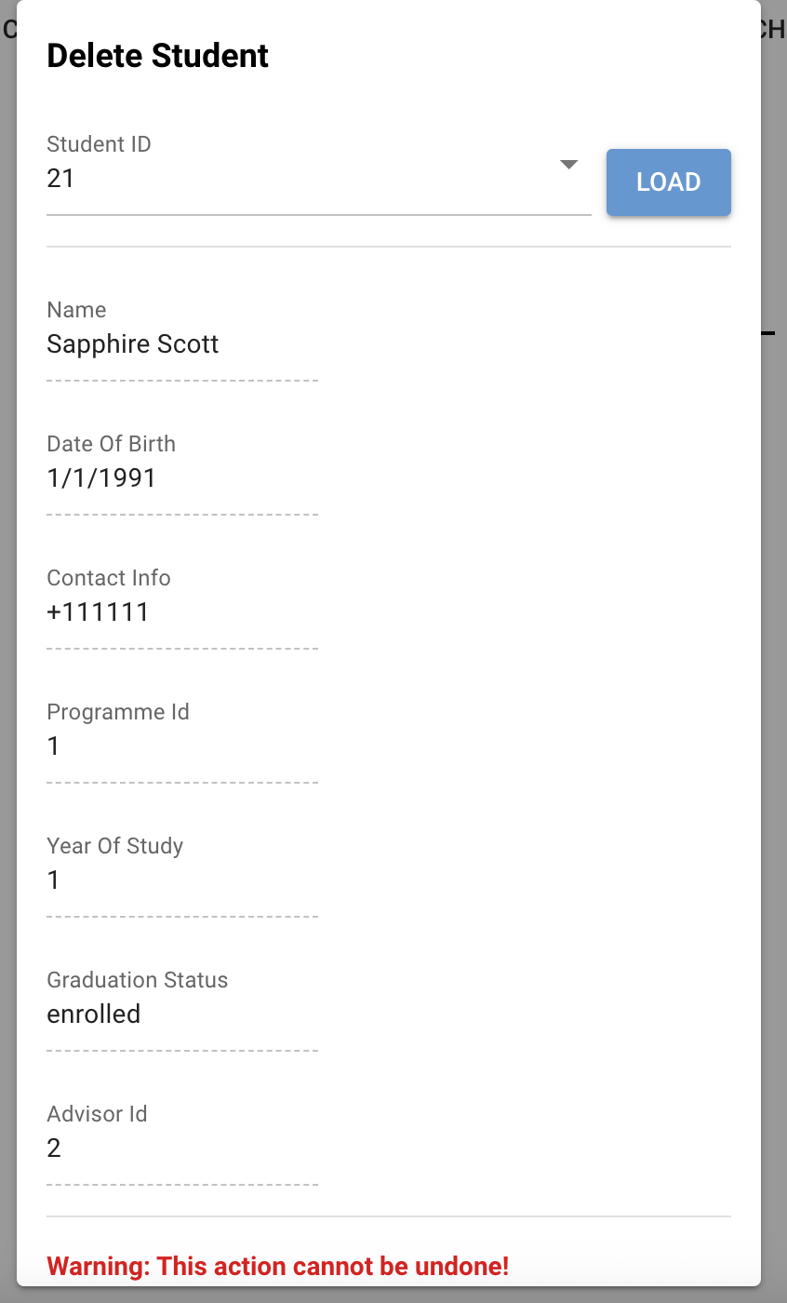

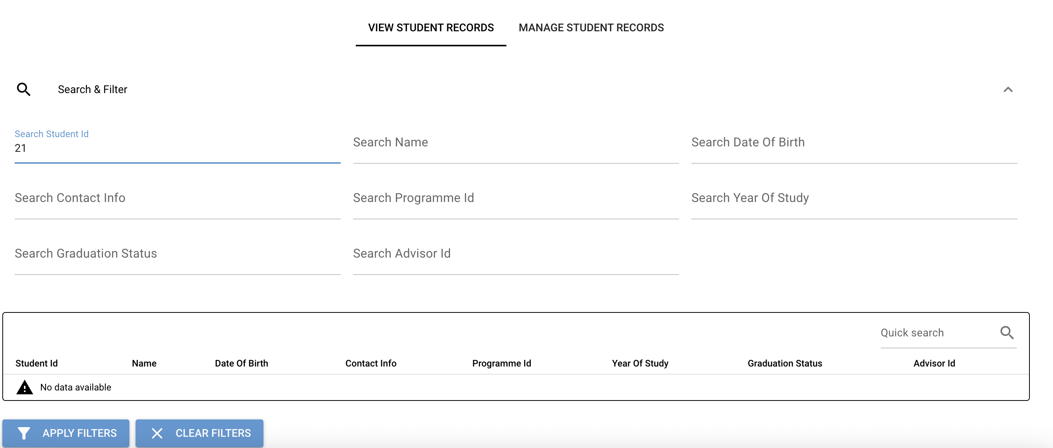

**Result:** Pass

**Lecturers – View lecturer records:  
  
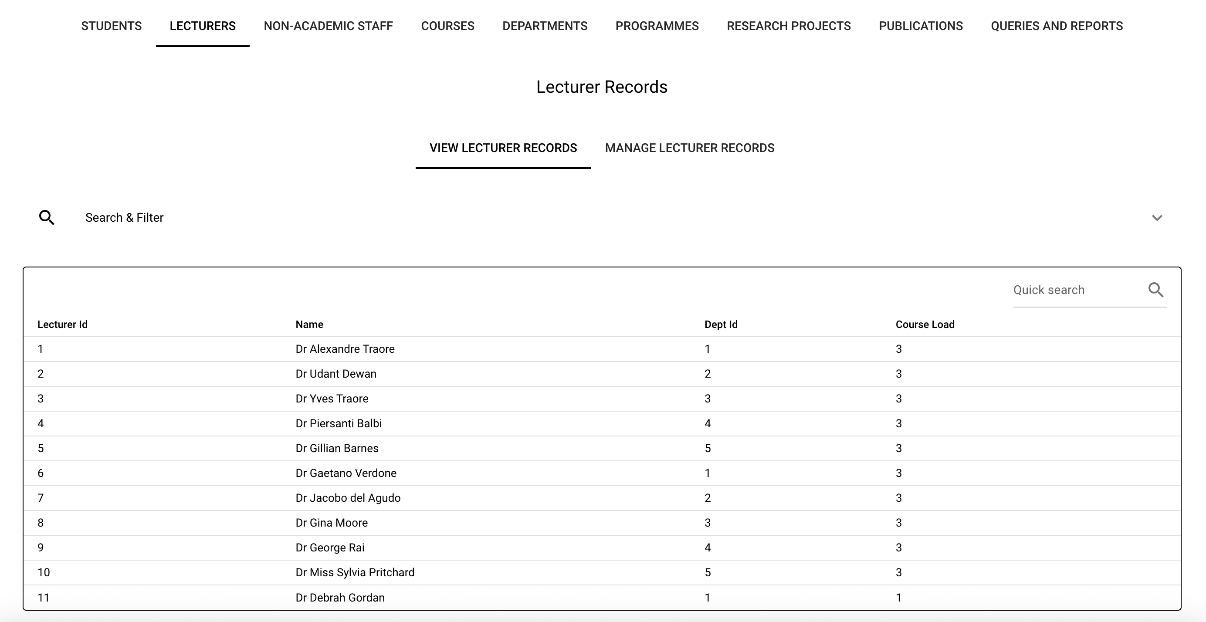**

**Search & Filter:**

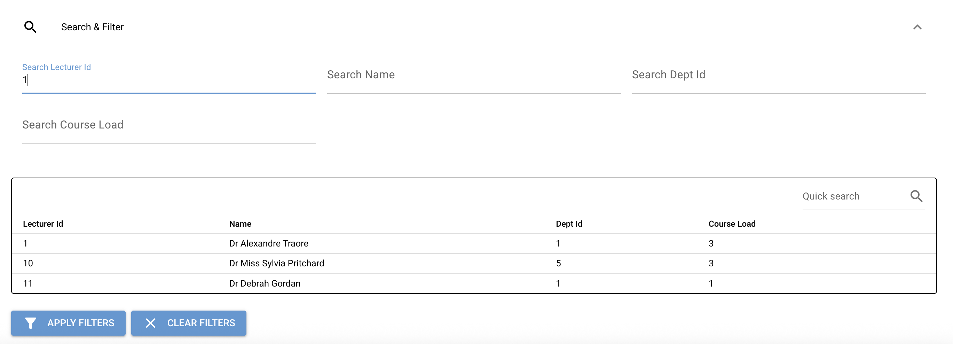

**Result:** Pass

**Manage Lecturer Records:**

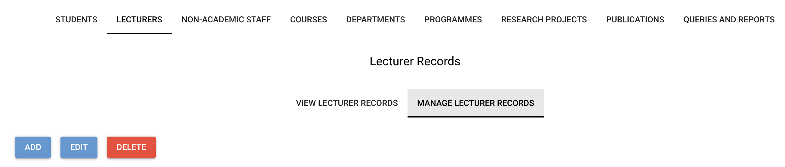

**Result:** Pass

**Add Lecturer:**

Future enhancement – add eror messages for missing fields

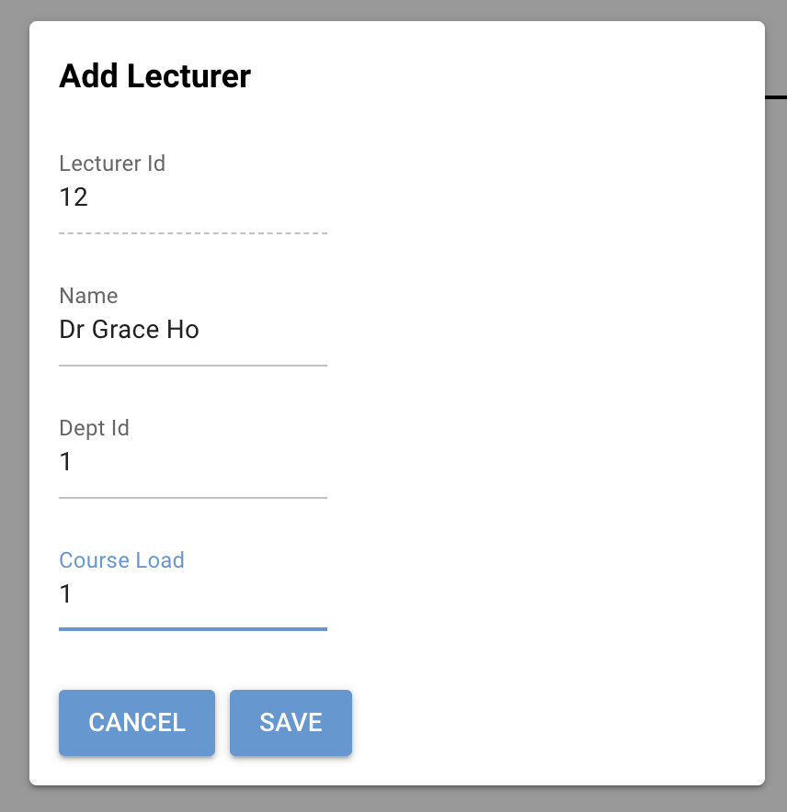

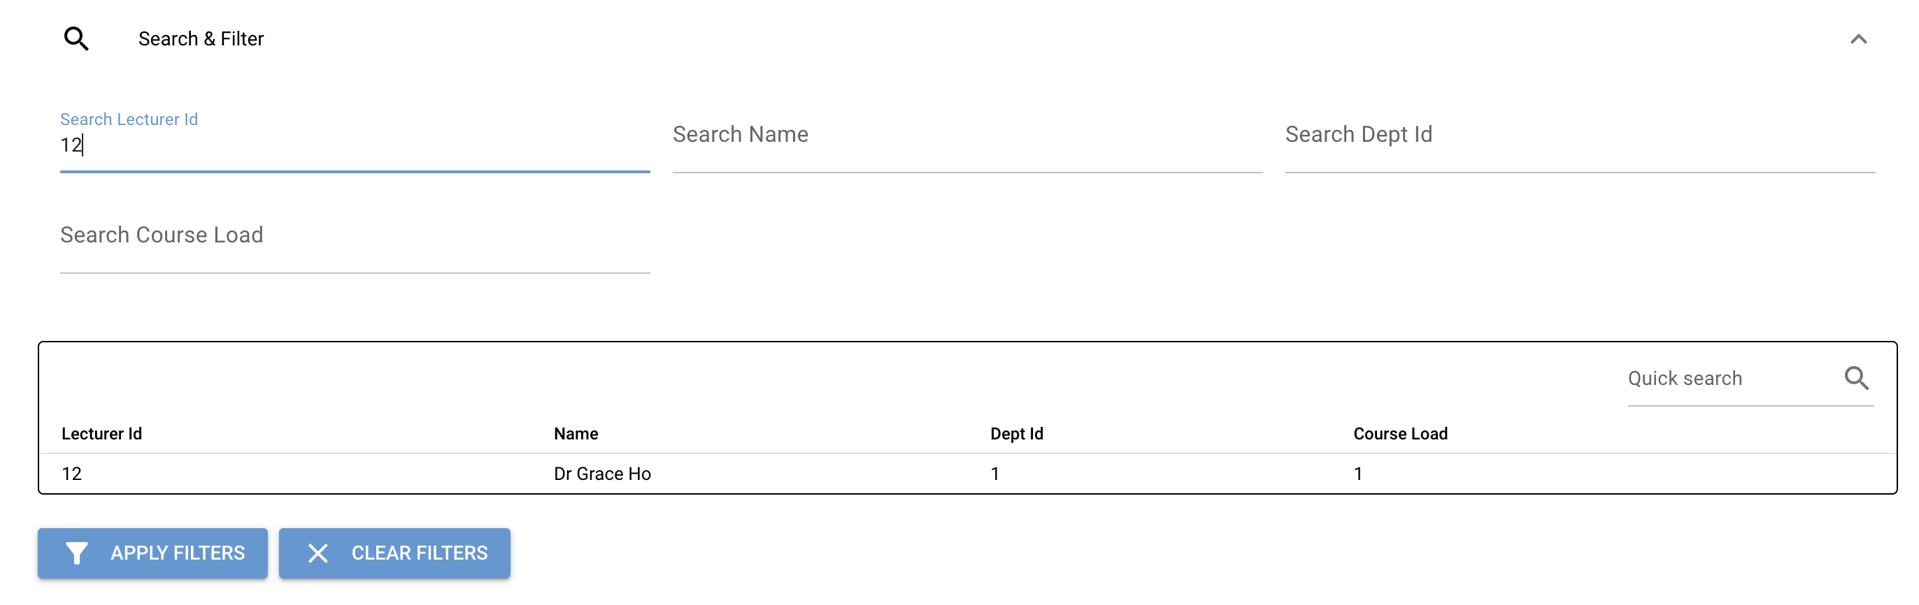

**Edit Lecturer:**

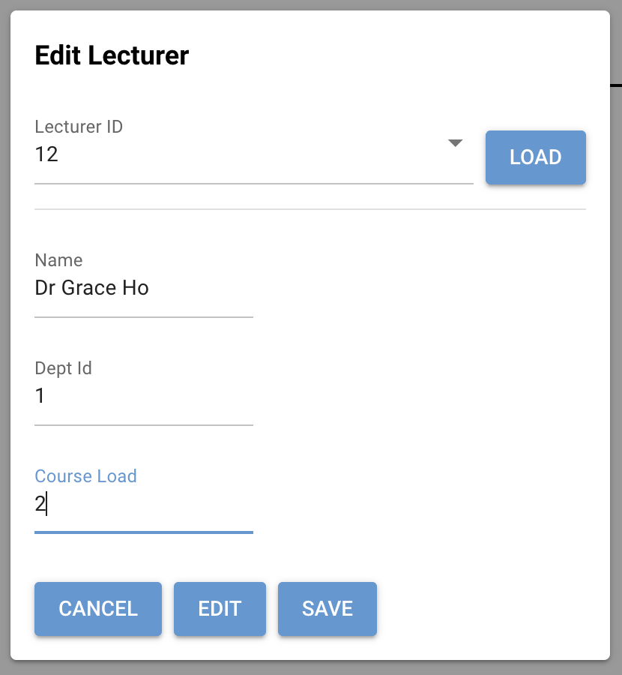

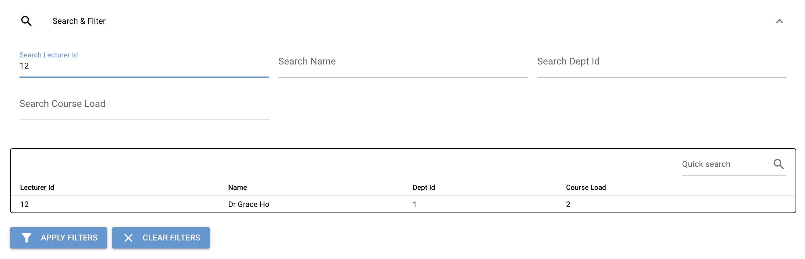

**Result:** Pass

Delete Lecturer:

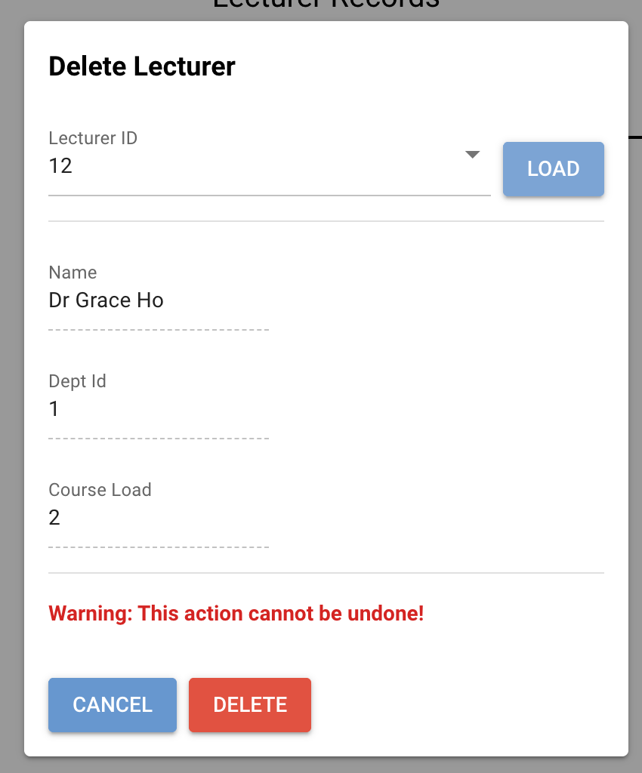

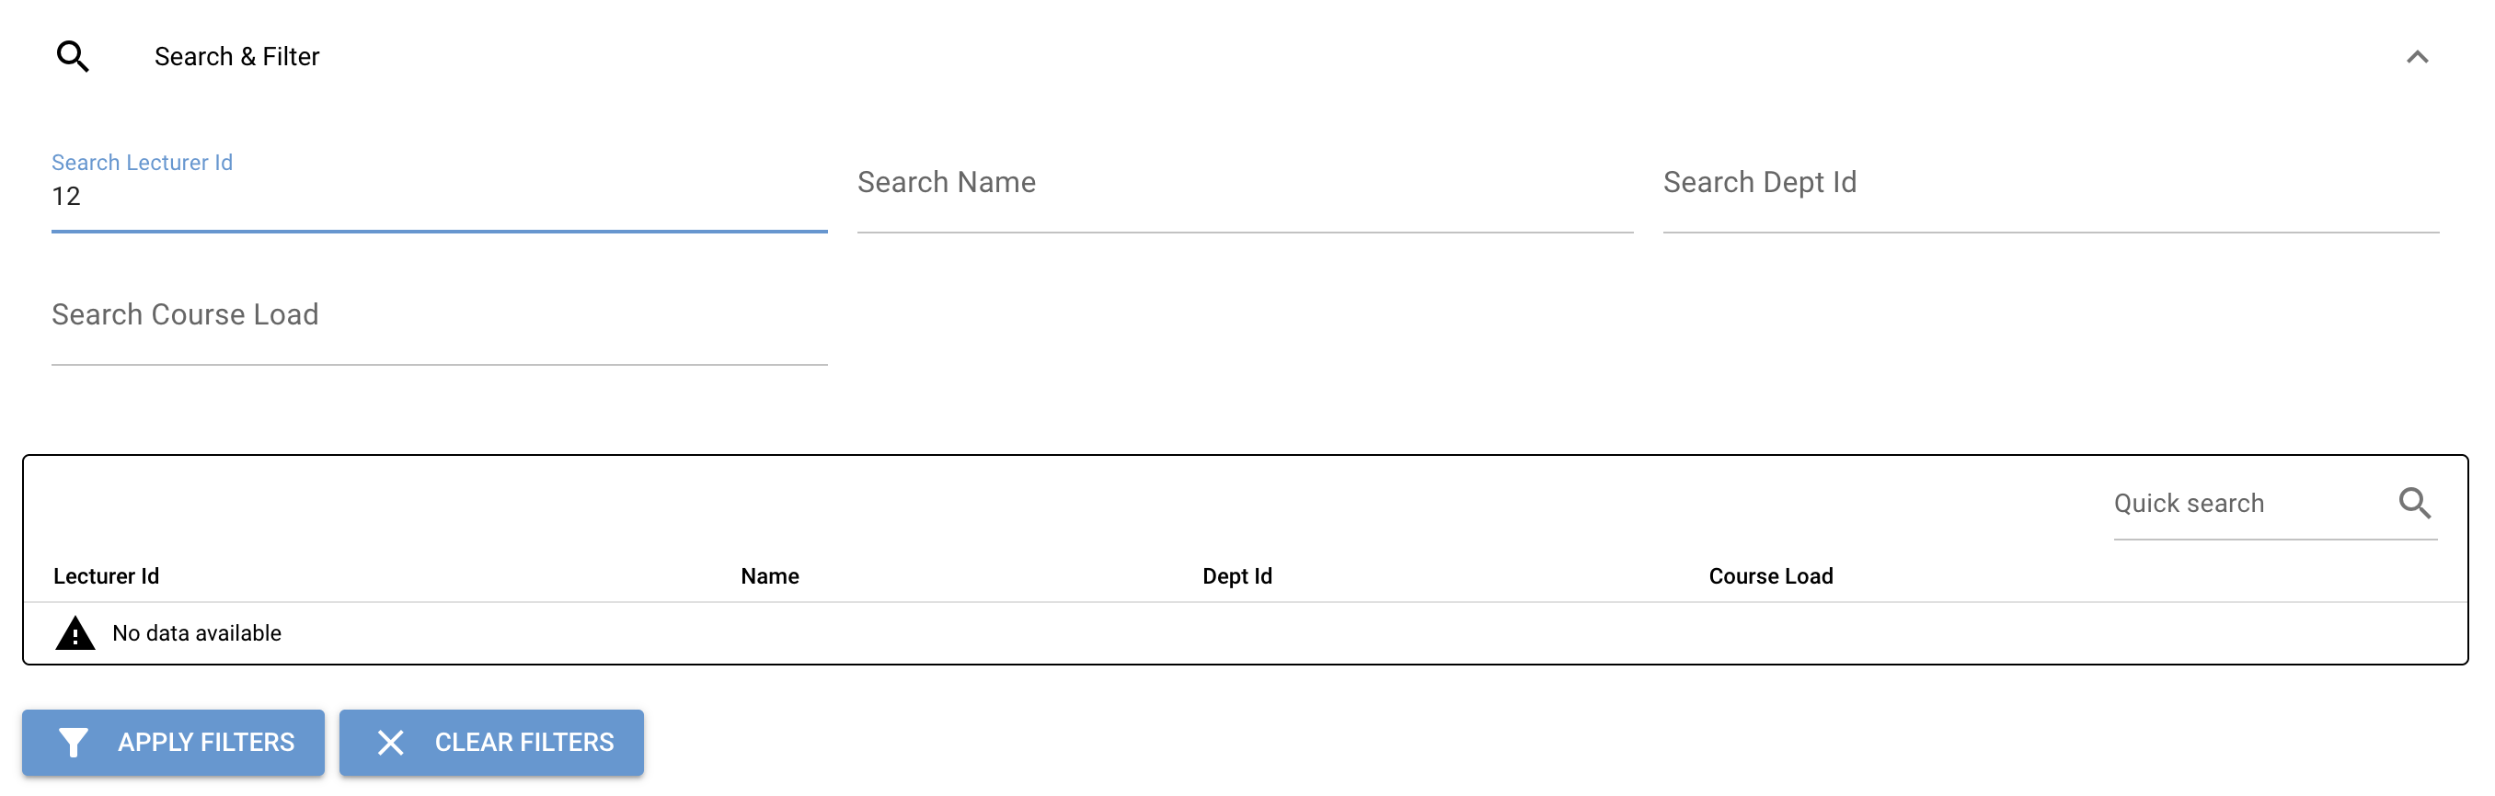

**Result:** Pass

**Non-academic staff – View non-academic staff records:  
  
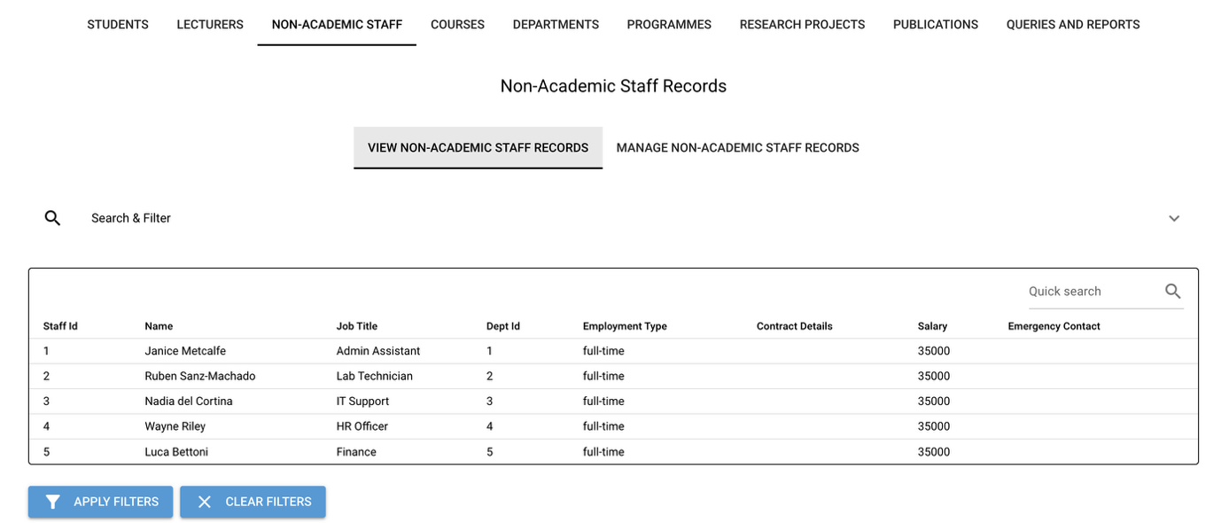**

**Search & Filter:**

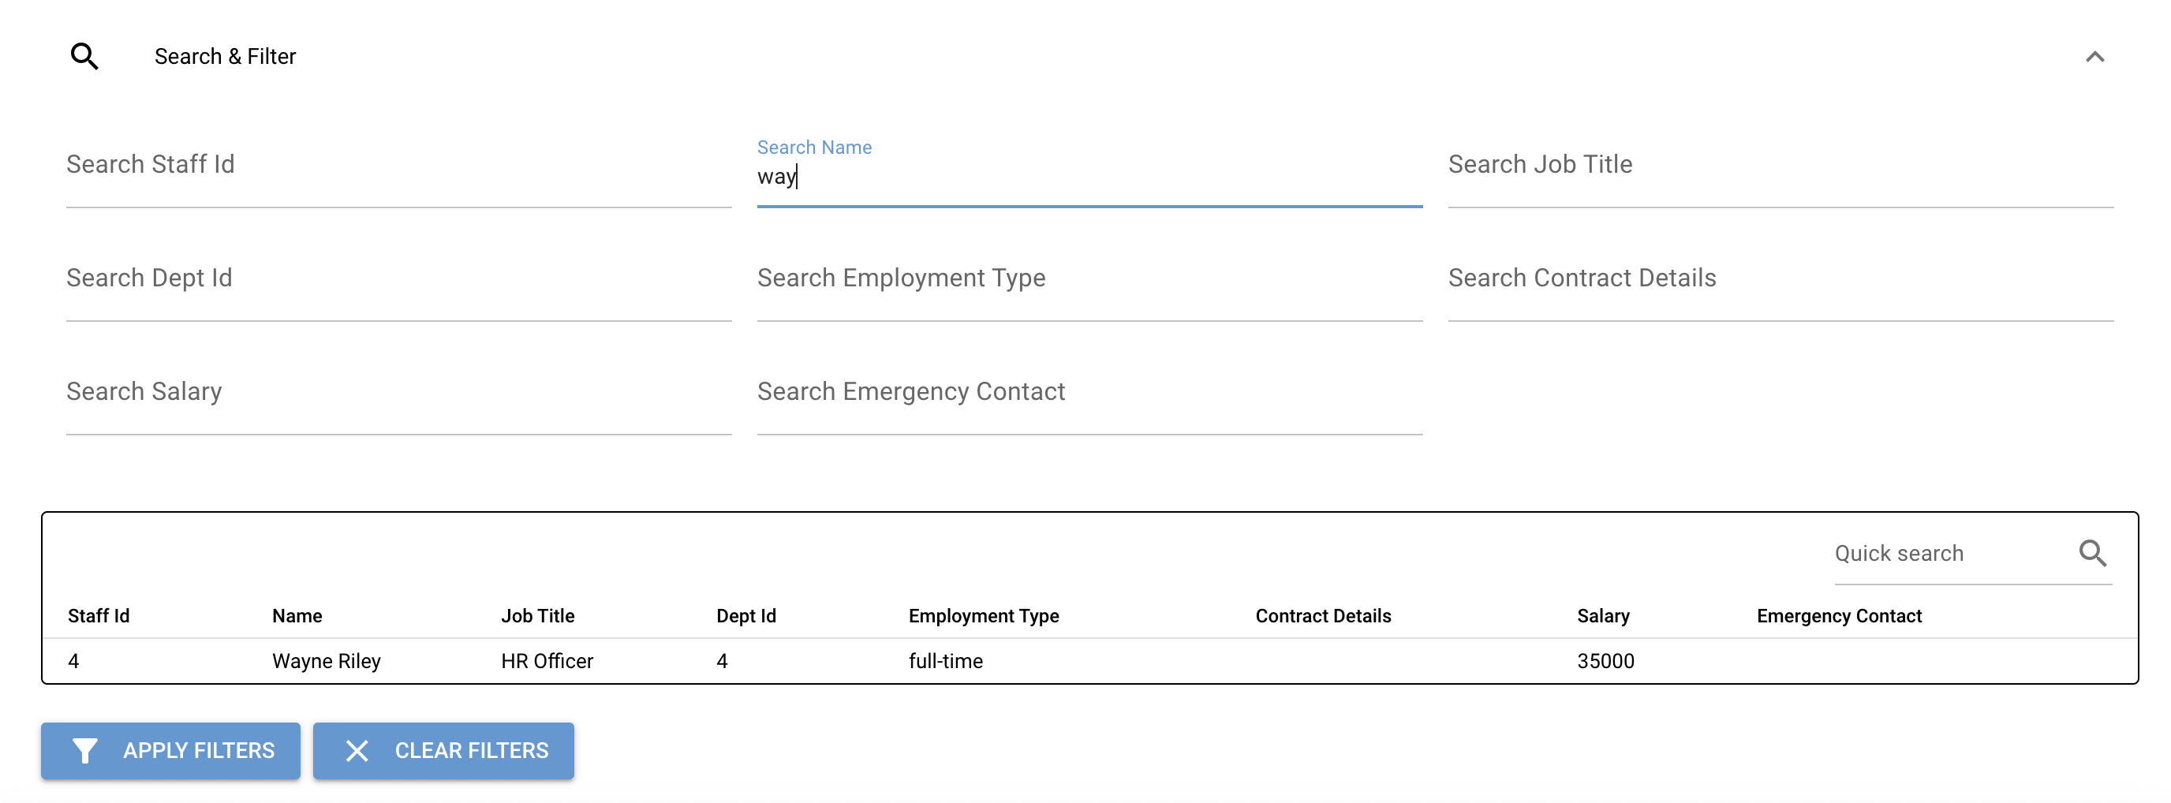

**Result:** Pass

**Manage non-academic staff Records:**

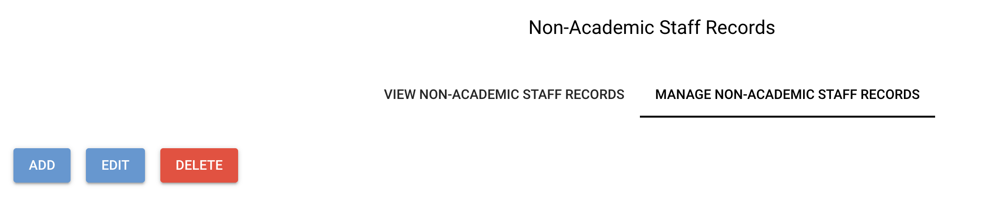

**Add non-academic staff:**

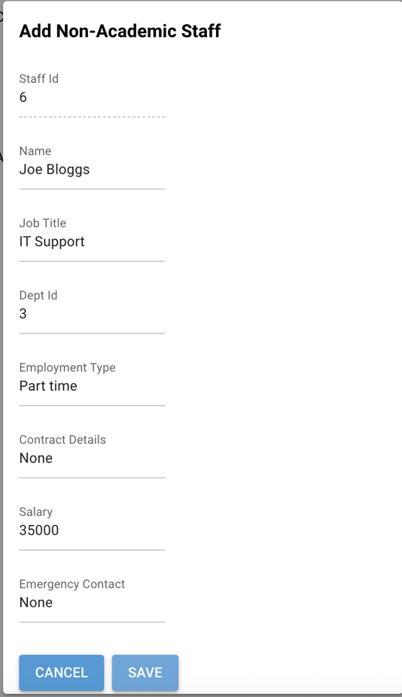

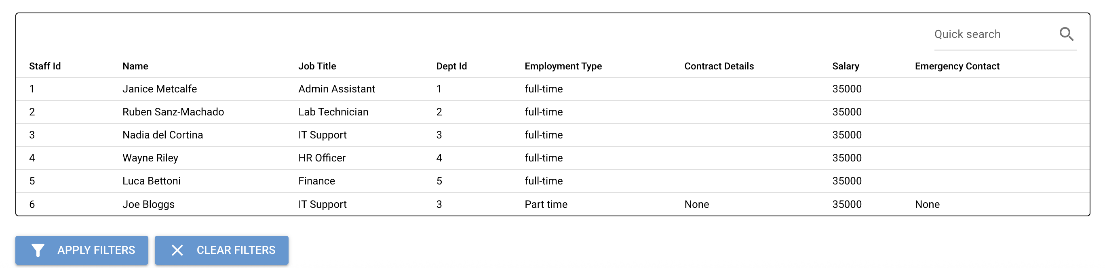

**Result:** Pass

**Edit non-academic staff:**

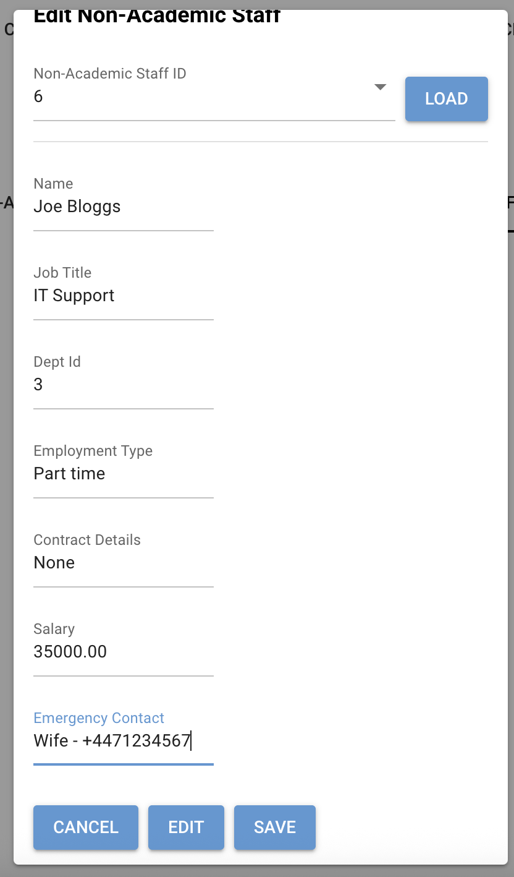

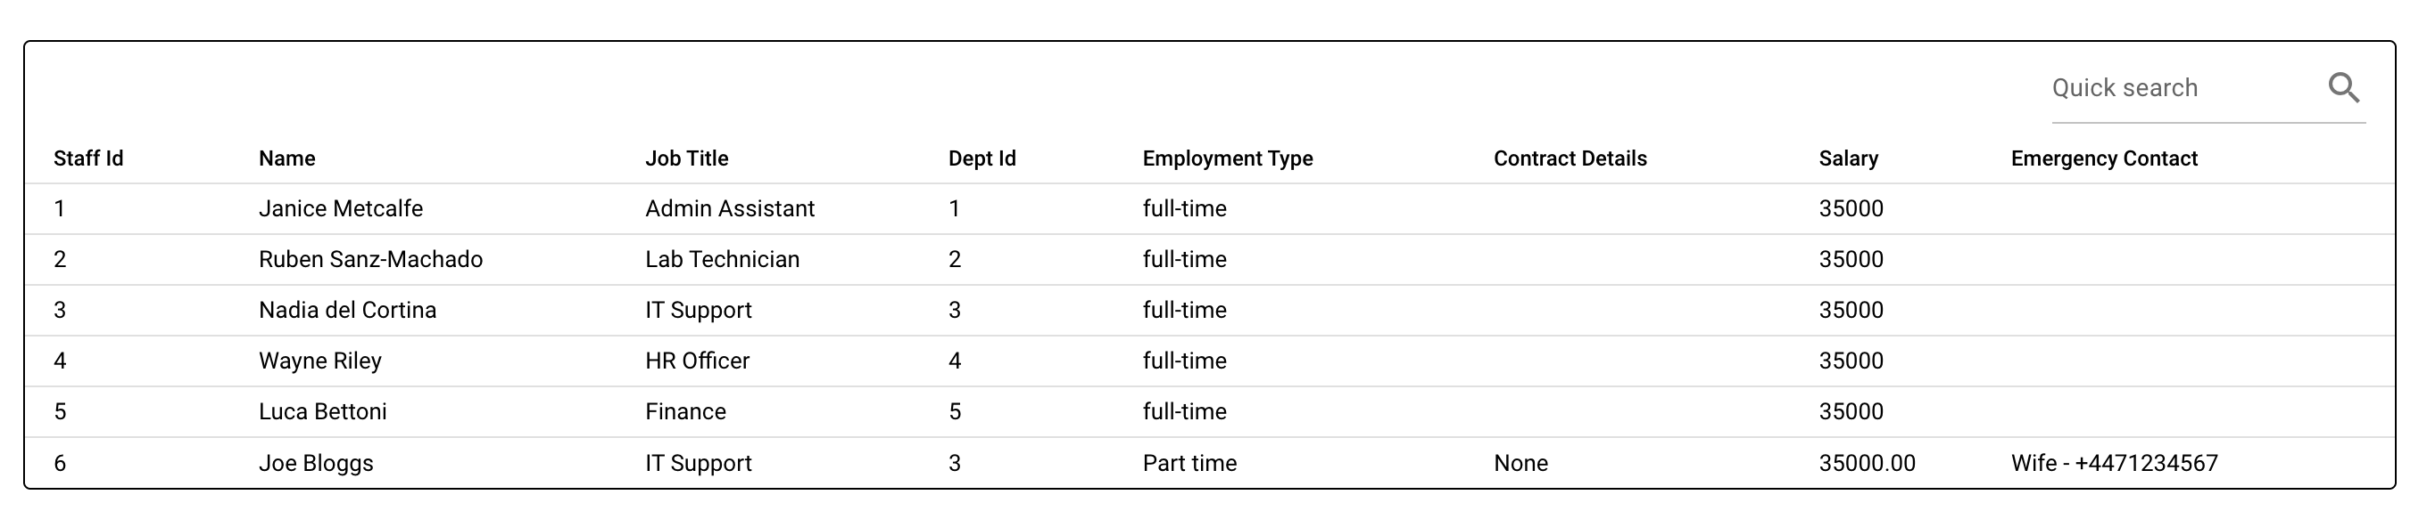

**Result:** Pass

**Delete non-academic staff:**

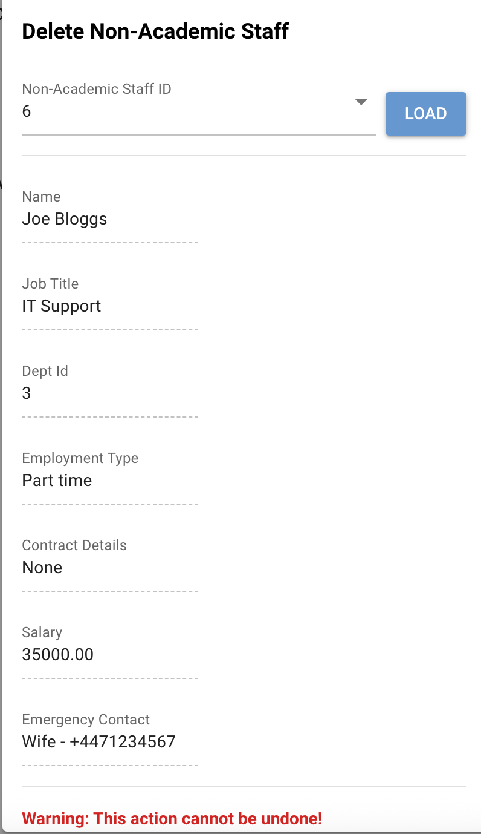

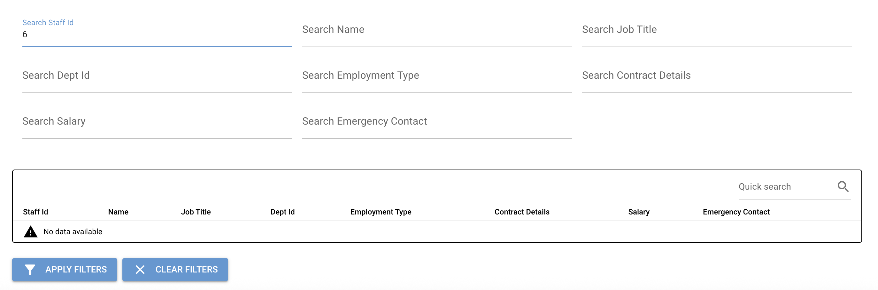

**Result:** Pass

**Courses – View courses records:**

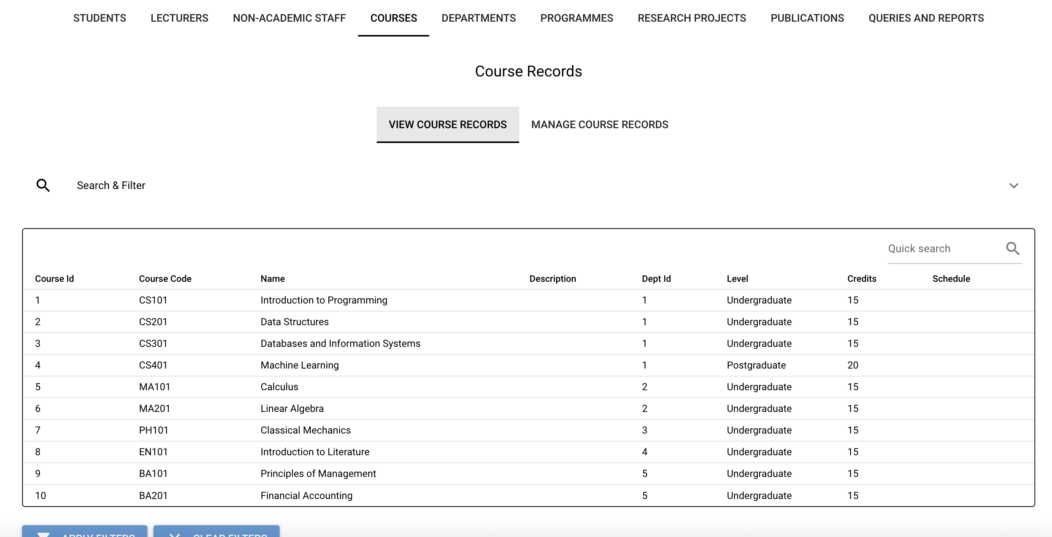

**Search & Filter:**

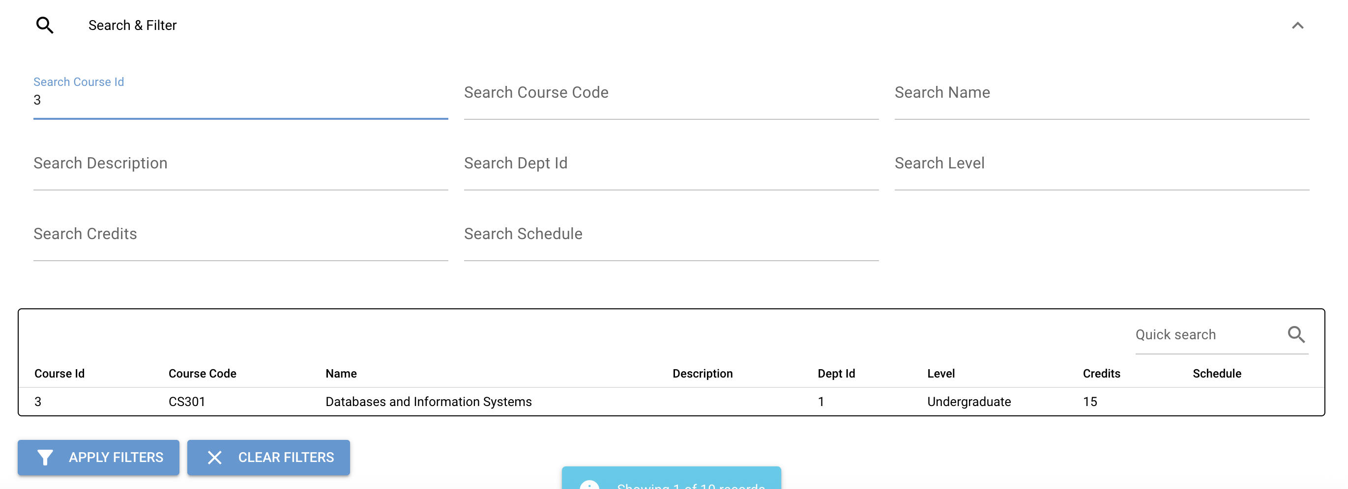

**Result:** Pass

**Manage course Records:**

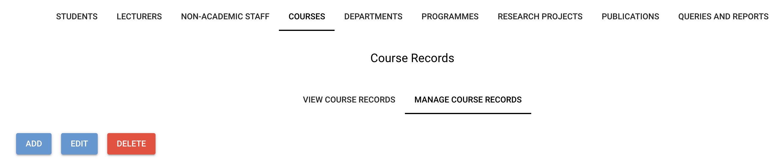

**Add courses:**

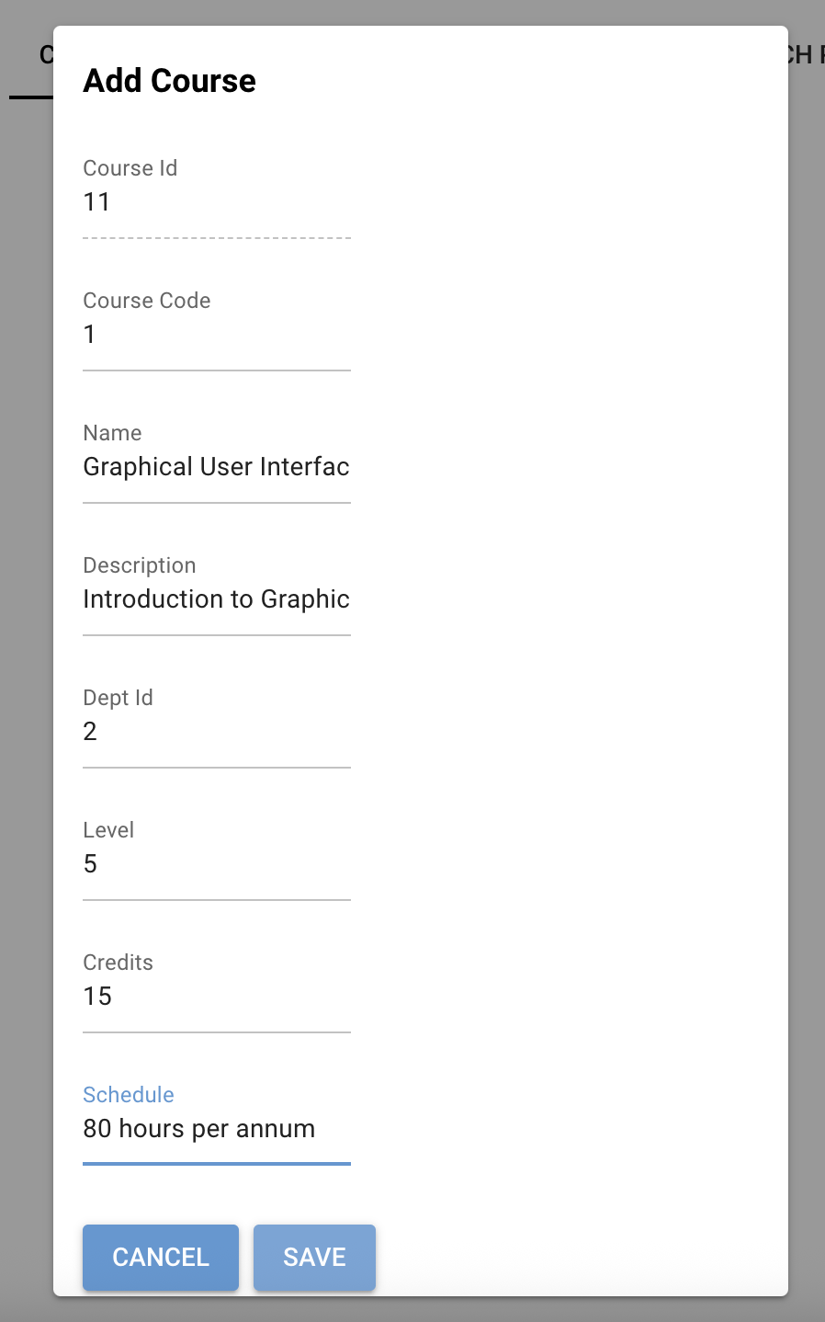

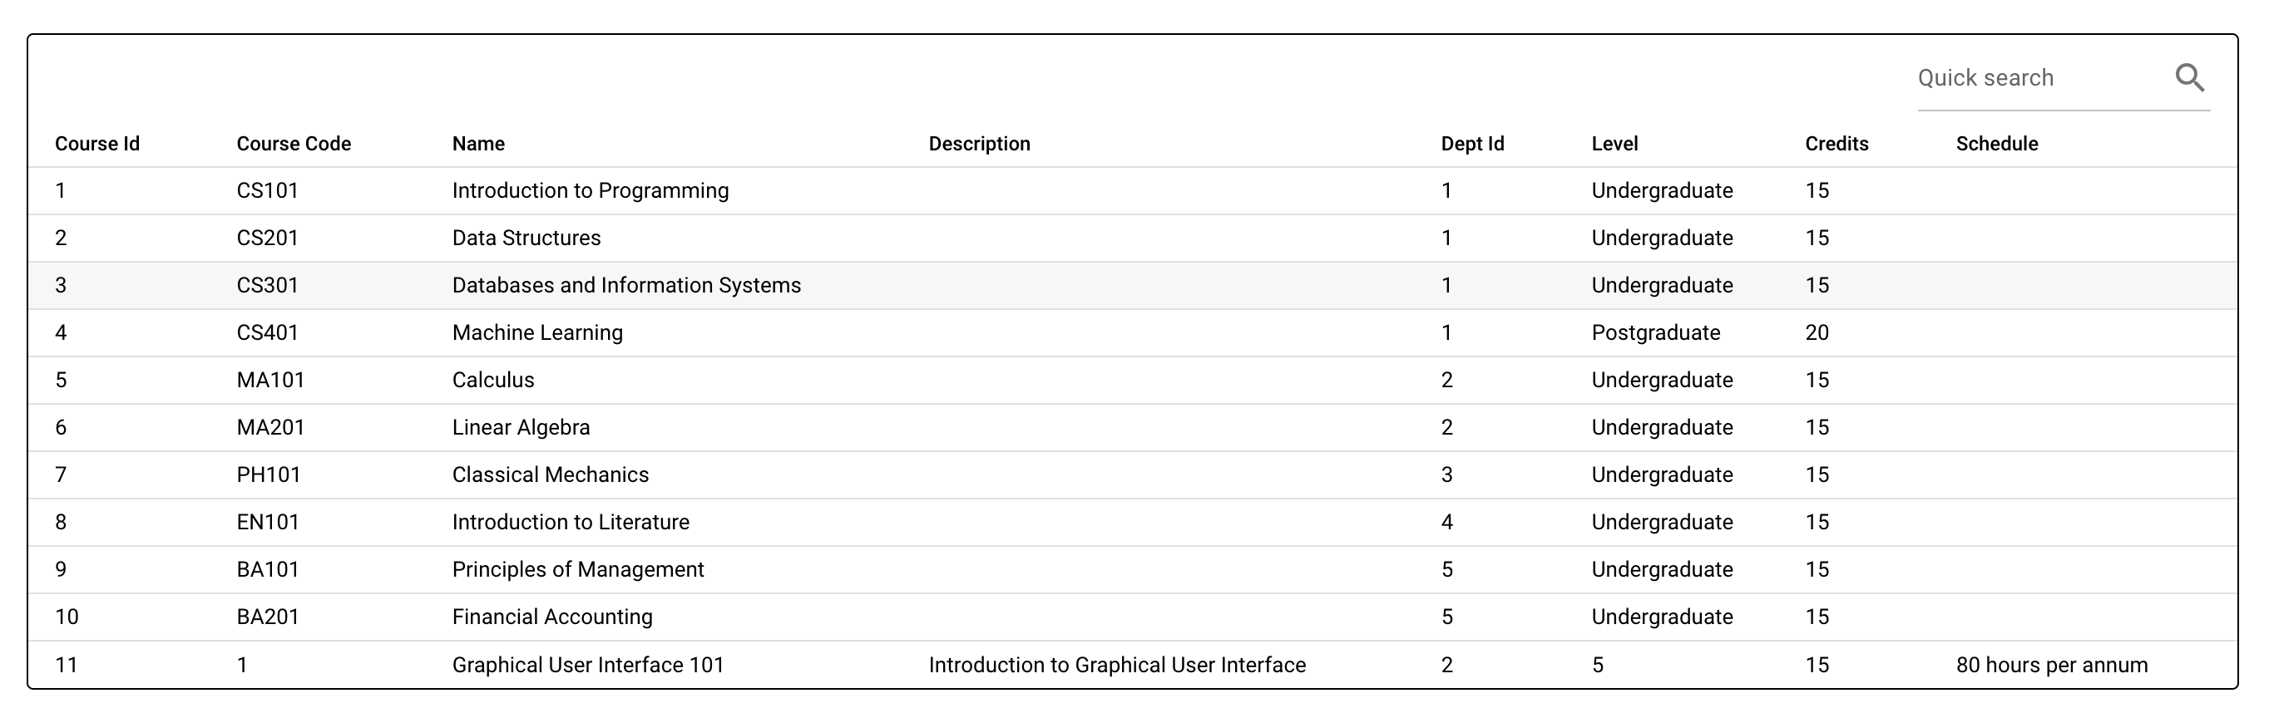

**Result:** Pass

**Edit courses:**

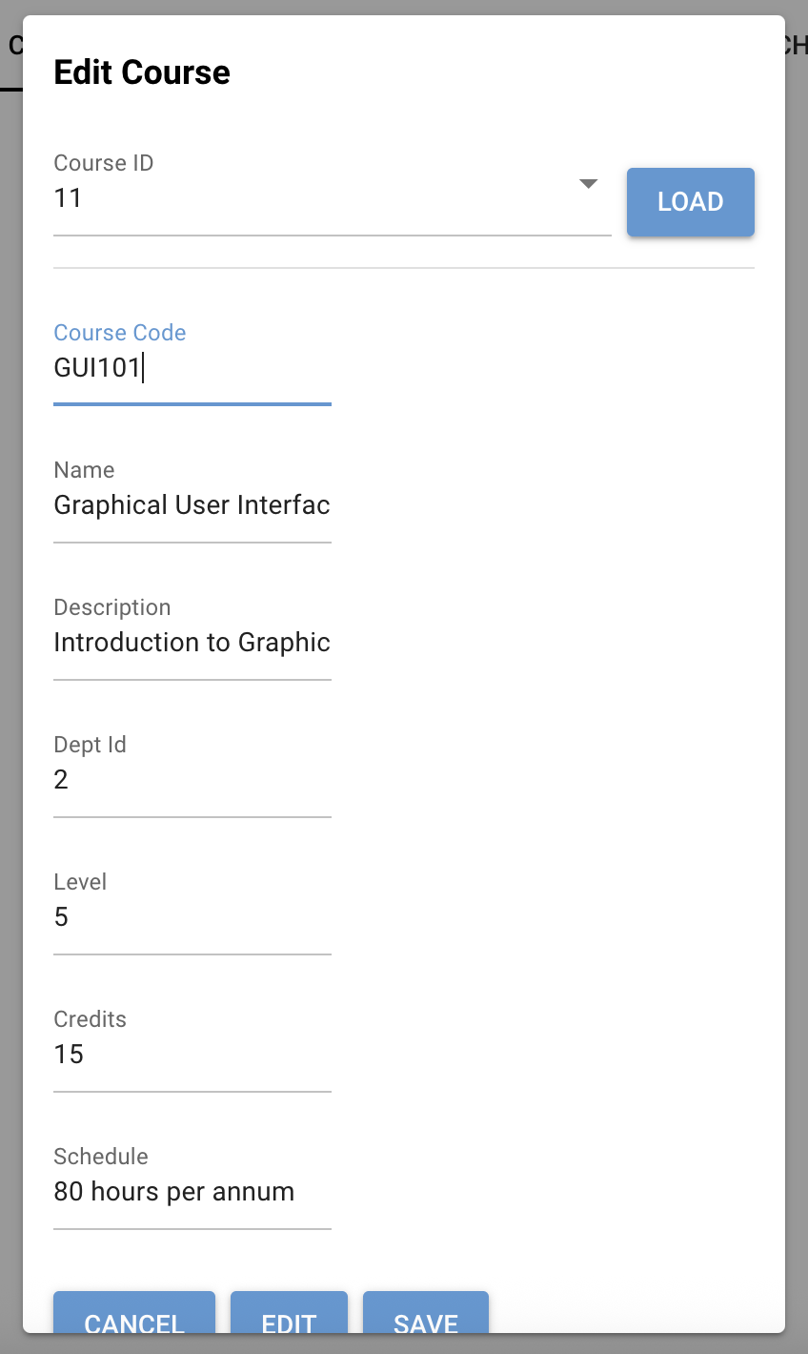

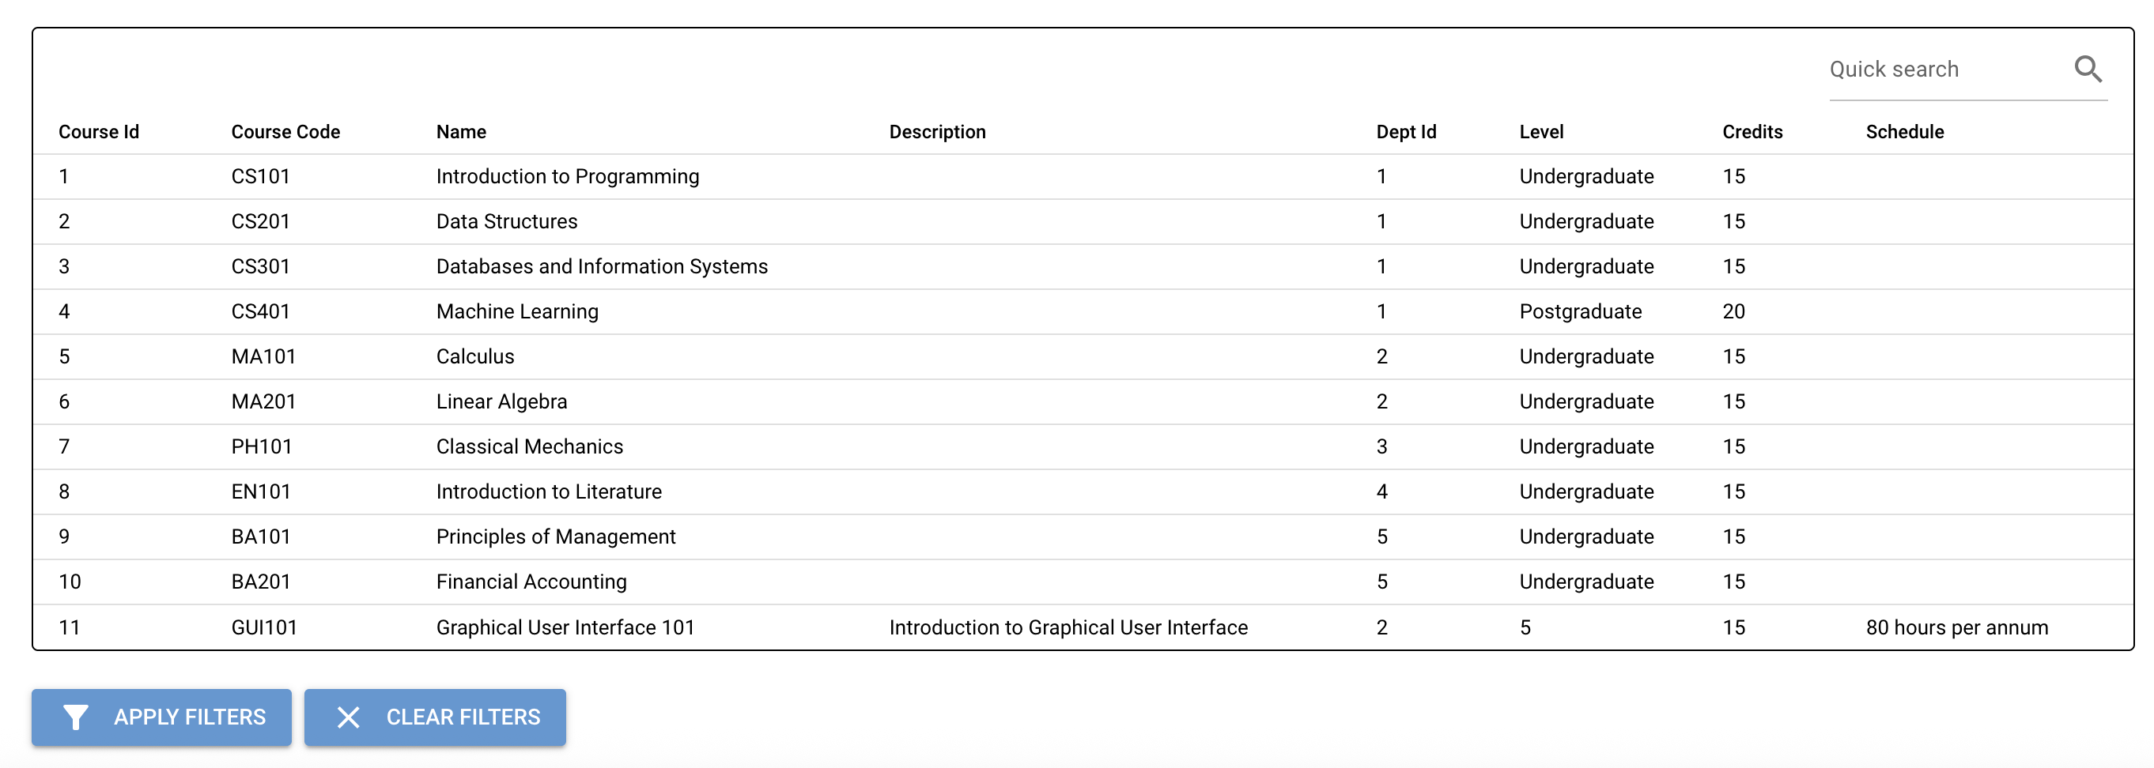

**Result:** Pass

**Delete courses:**

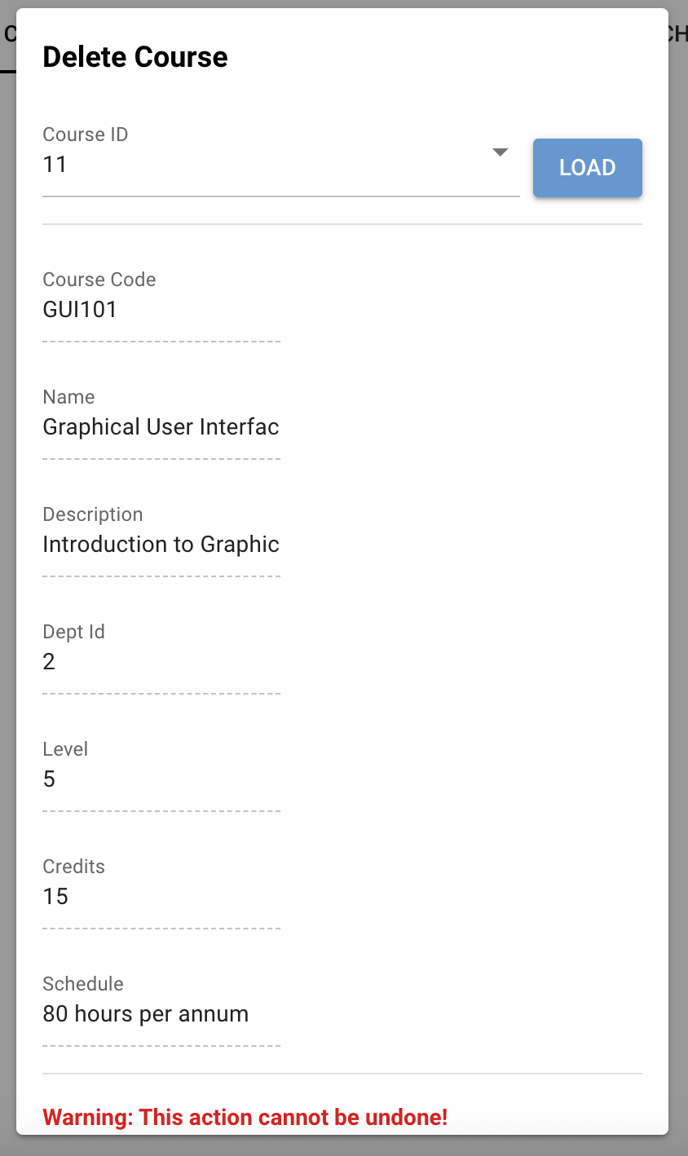

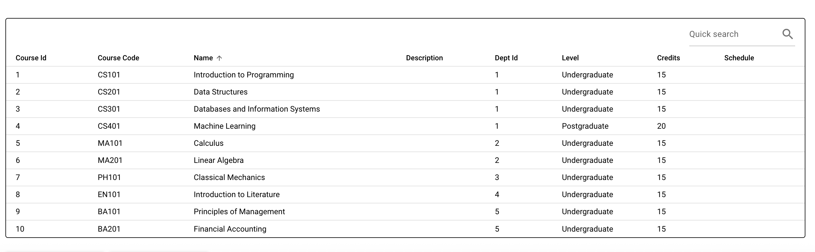

**Result:** Pass

**Departments – View department records:**

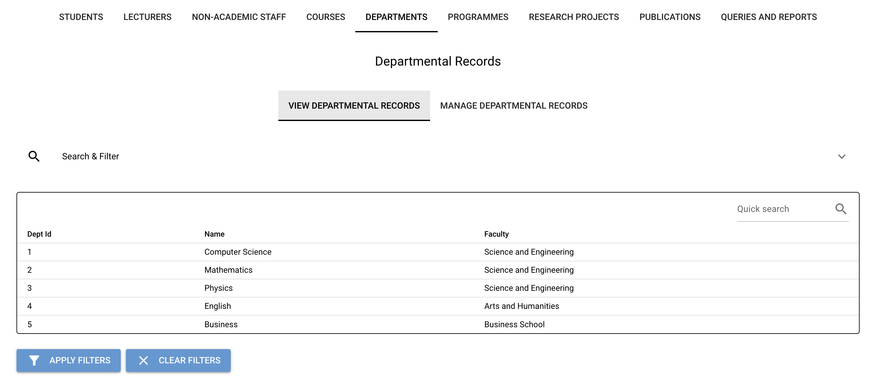

**Search & Filter:**

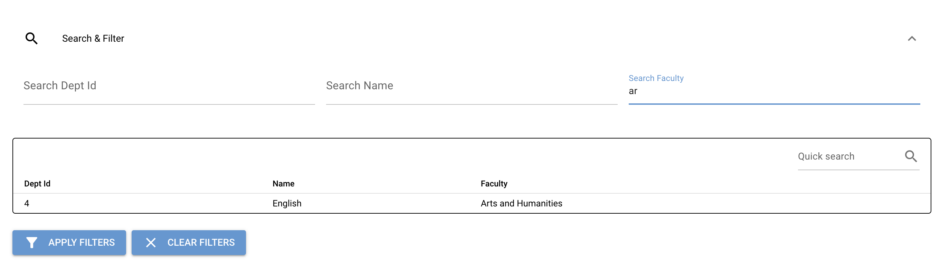

**Result:** Pass

**Manage department Records:**

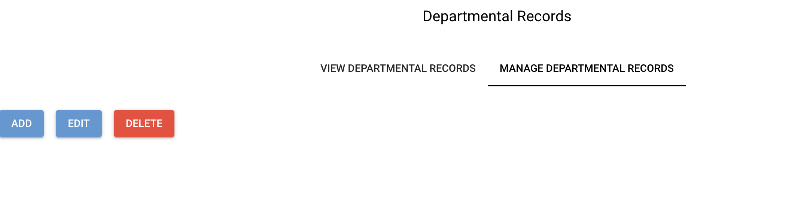

**Add department:**

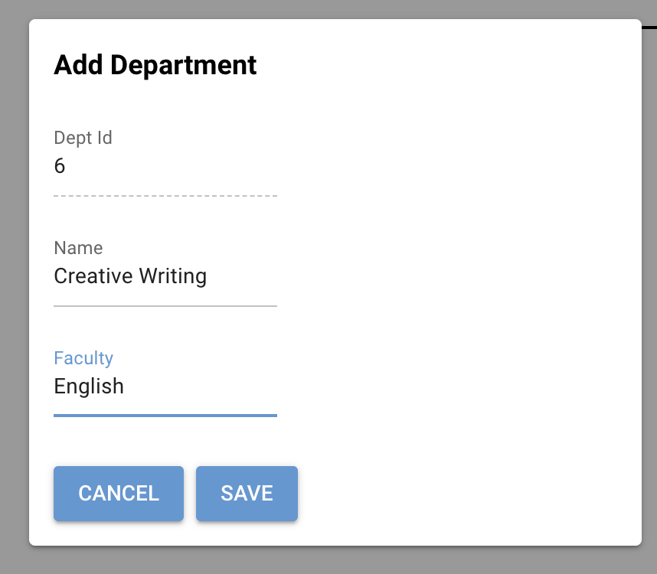

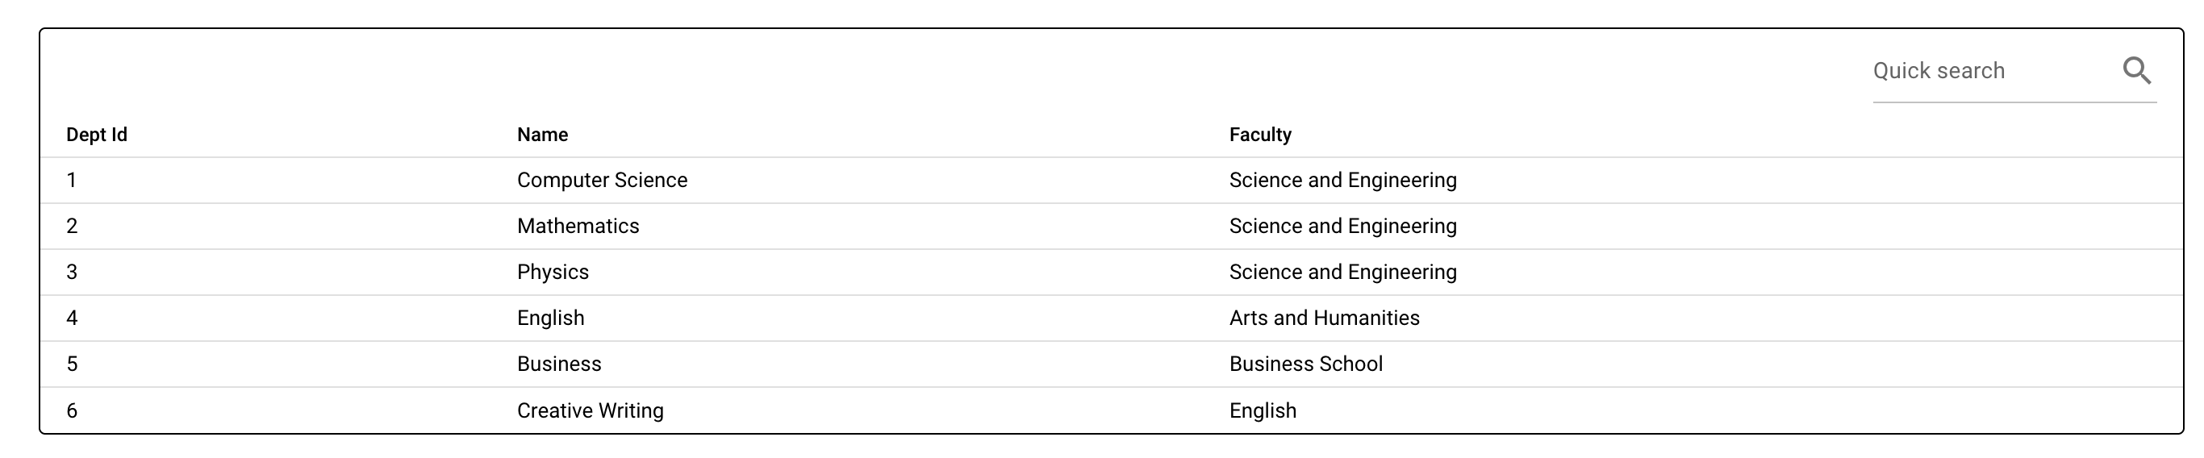

**Result:** Pass

**Edit department:**

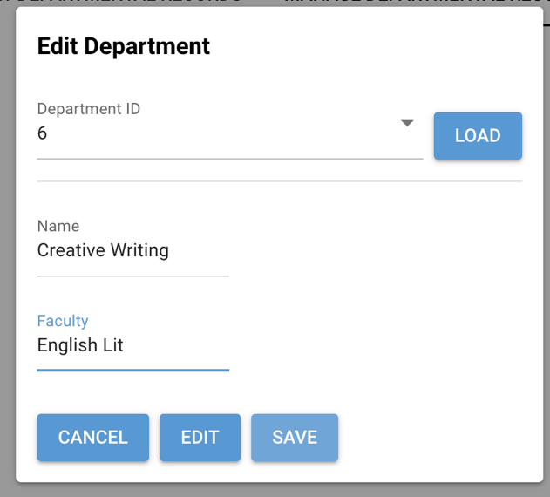

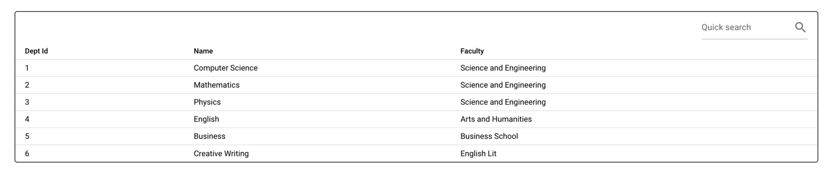

**Result:** Pass

**Delete department:**

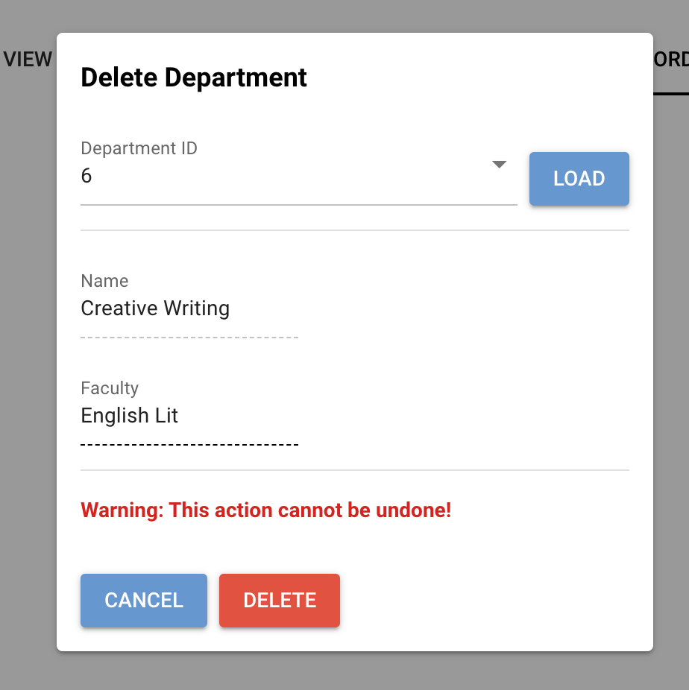

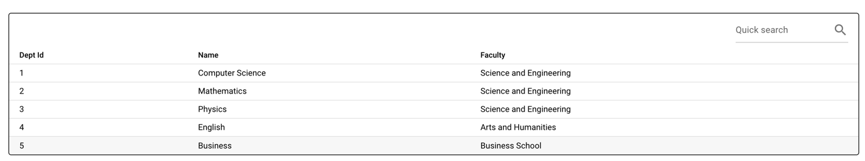

**Programmes – View programme records:**

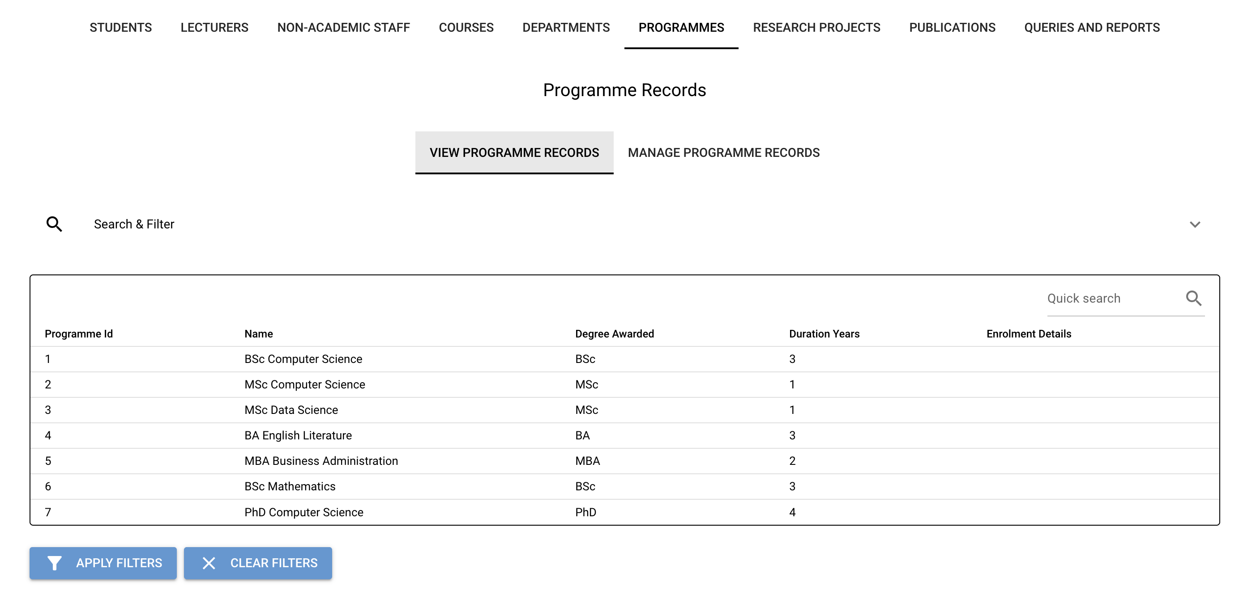

**Search & Filter:**

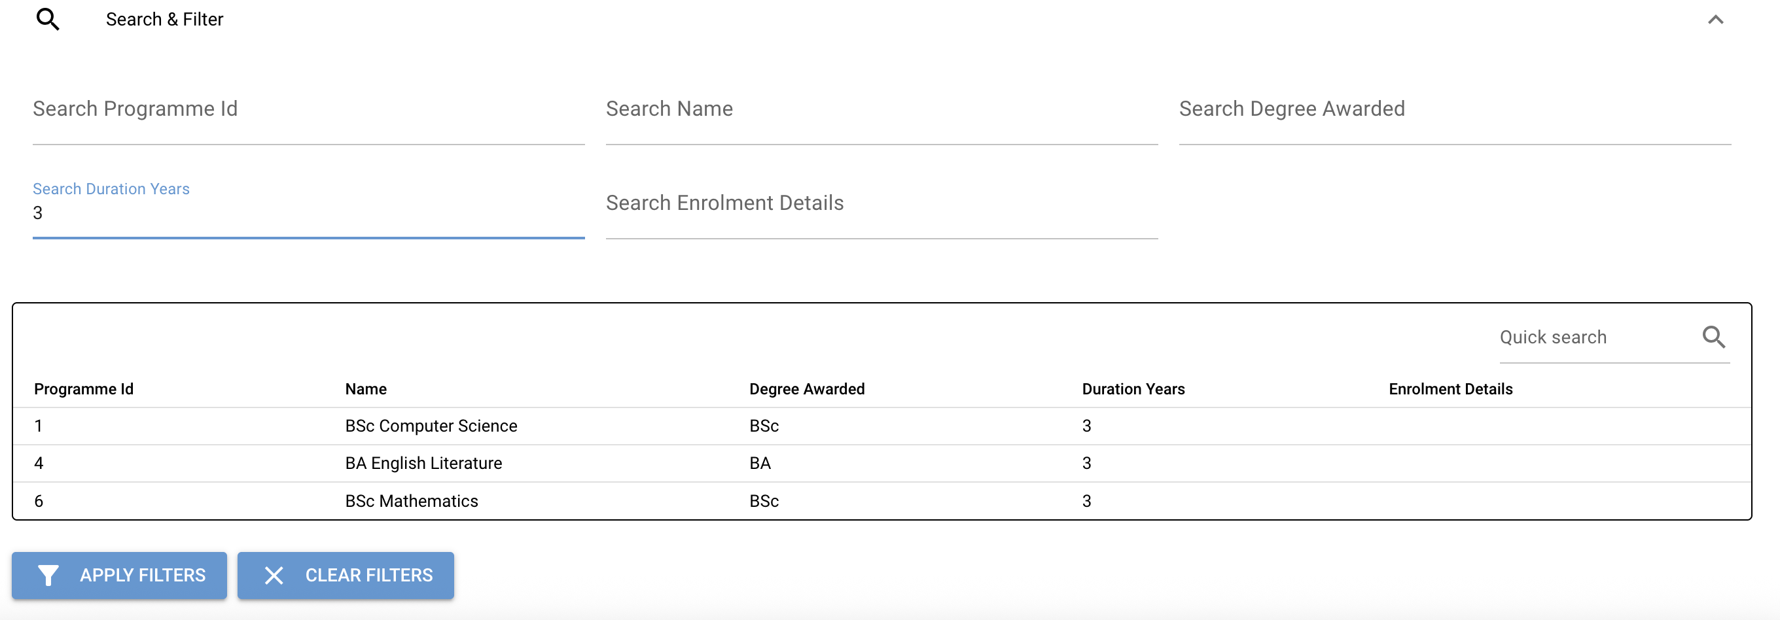

**Result:** Pass

**Manage programmes Records:**

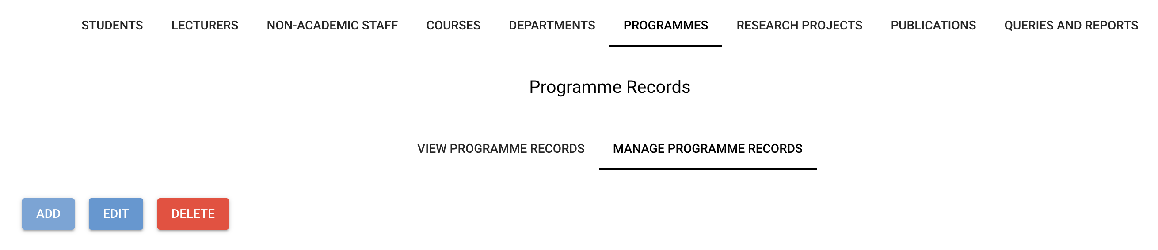

**Add programmes:**

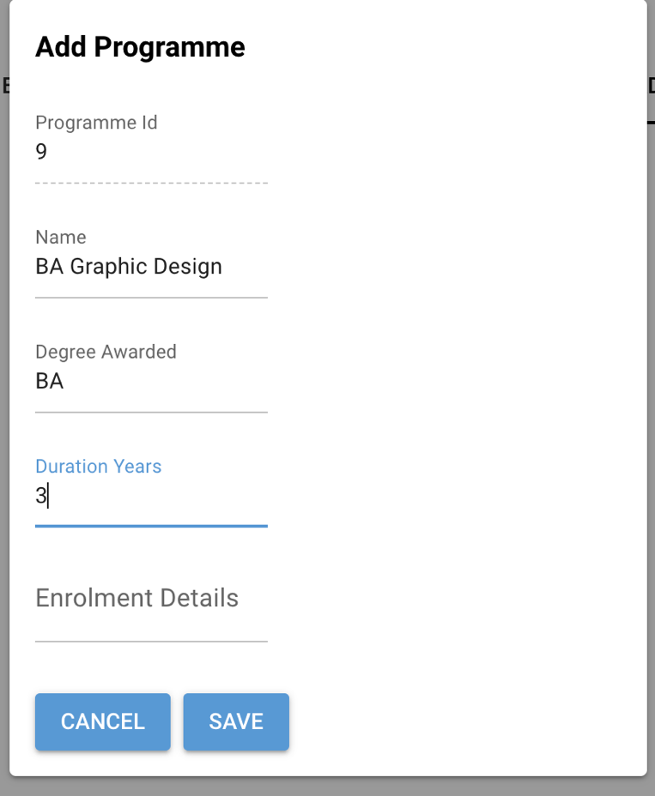

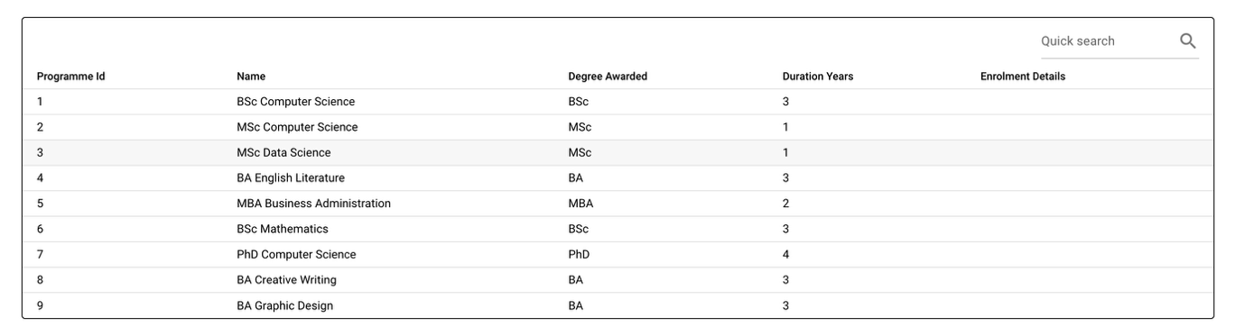

**Result:** Pass

**Edit programmes:**

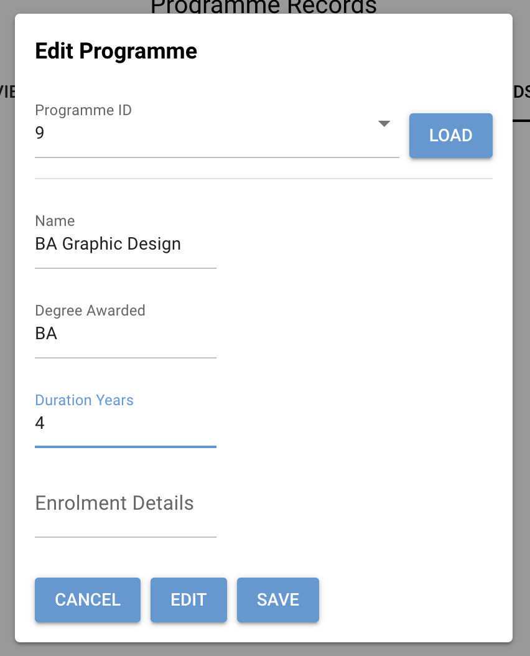

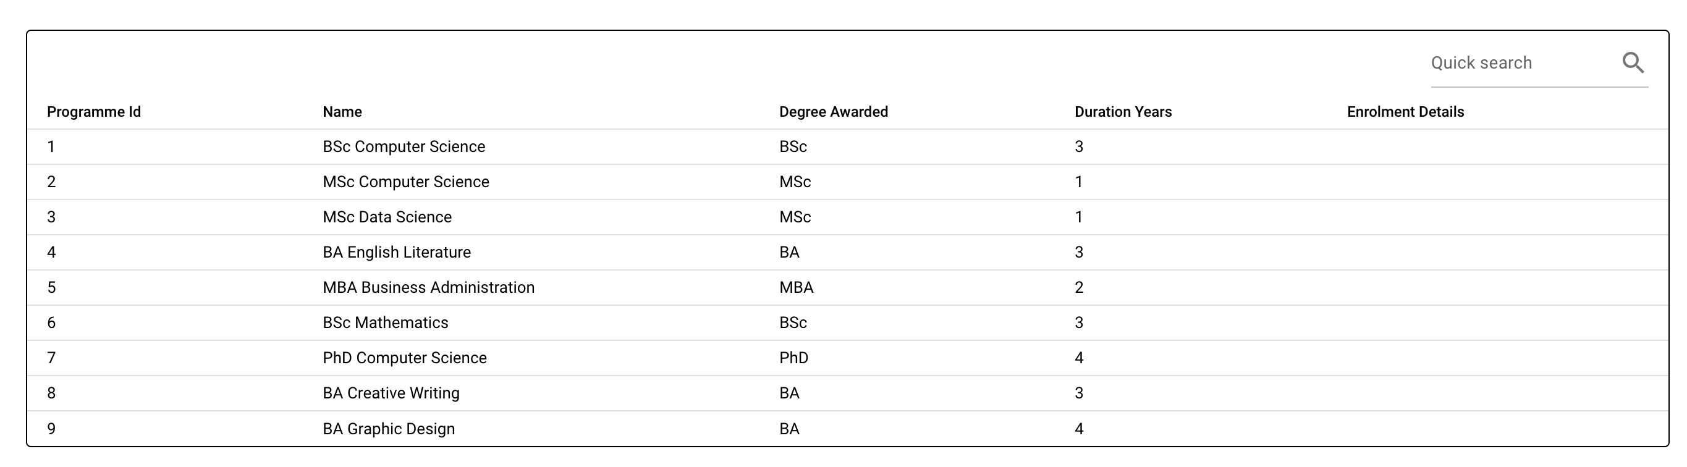

**Result:** Pass

**Delete programmes:**

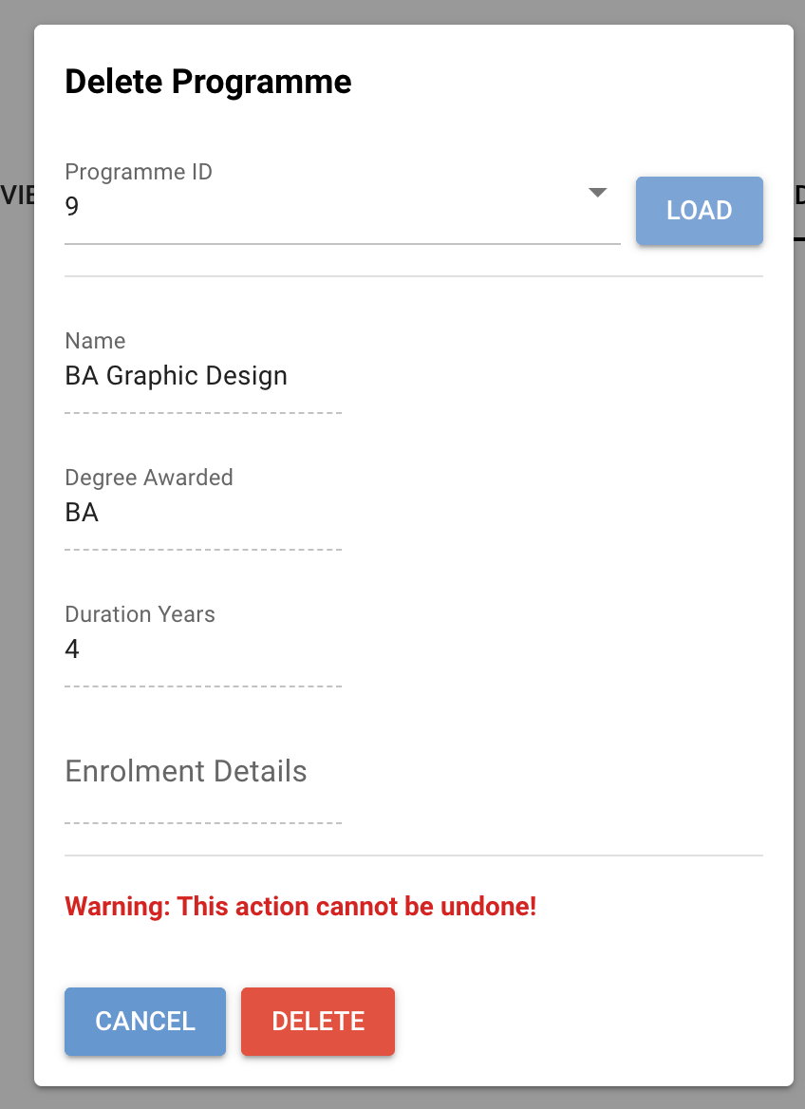

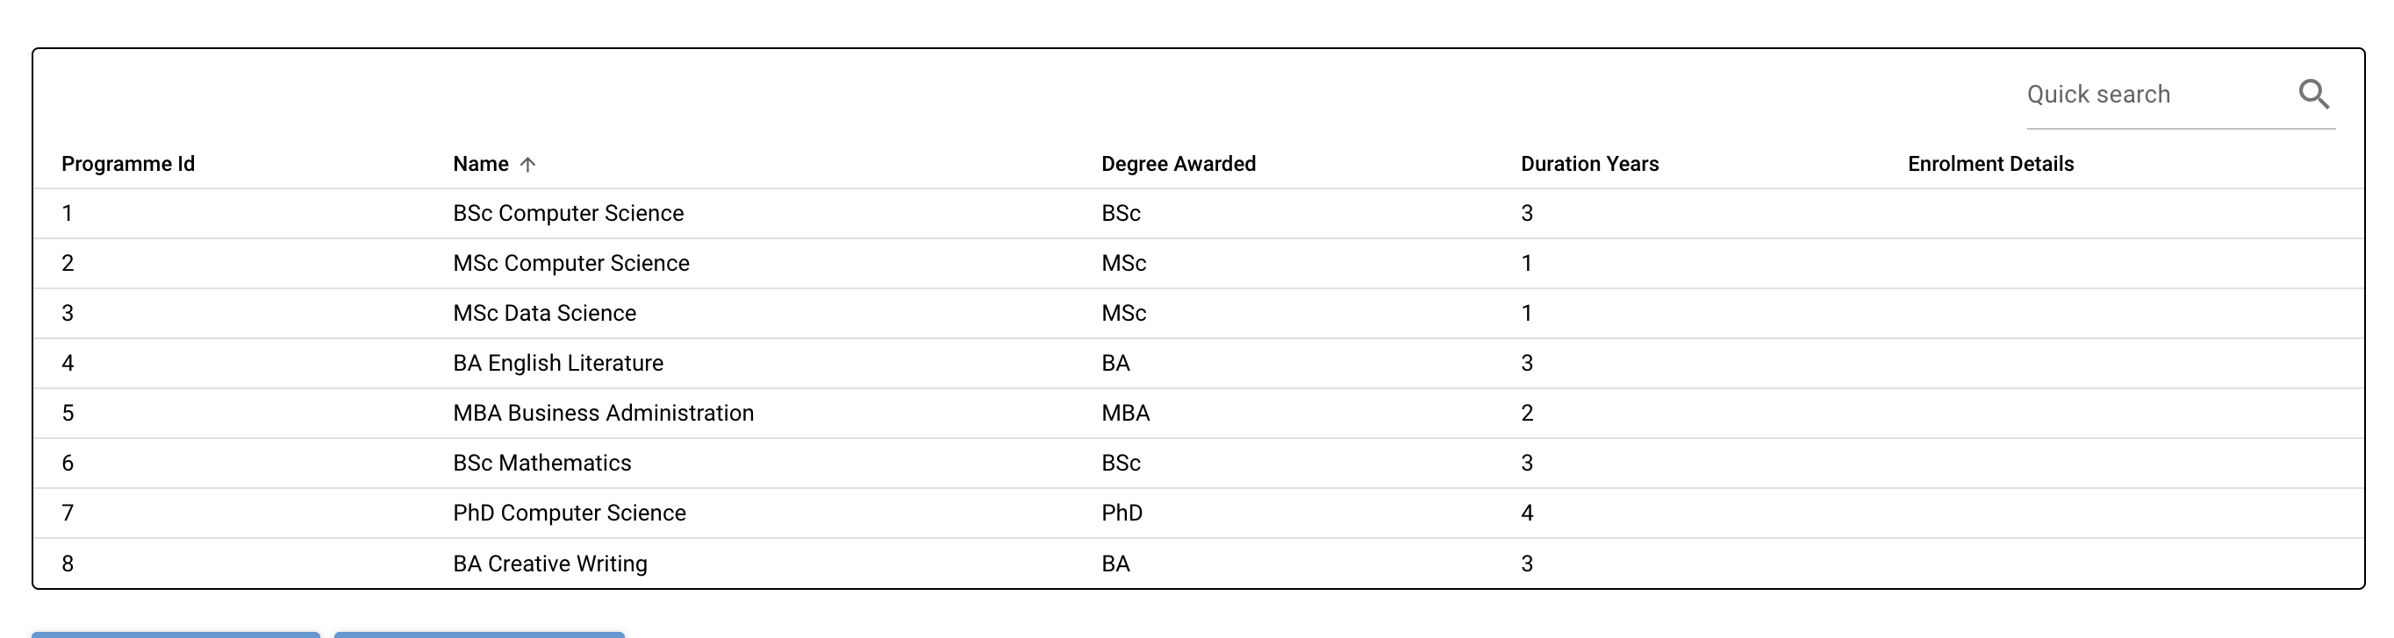

**Result:** Pass

**Research projects – View research projects records:**

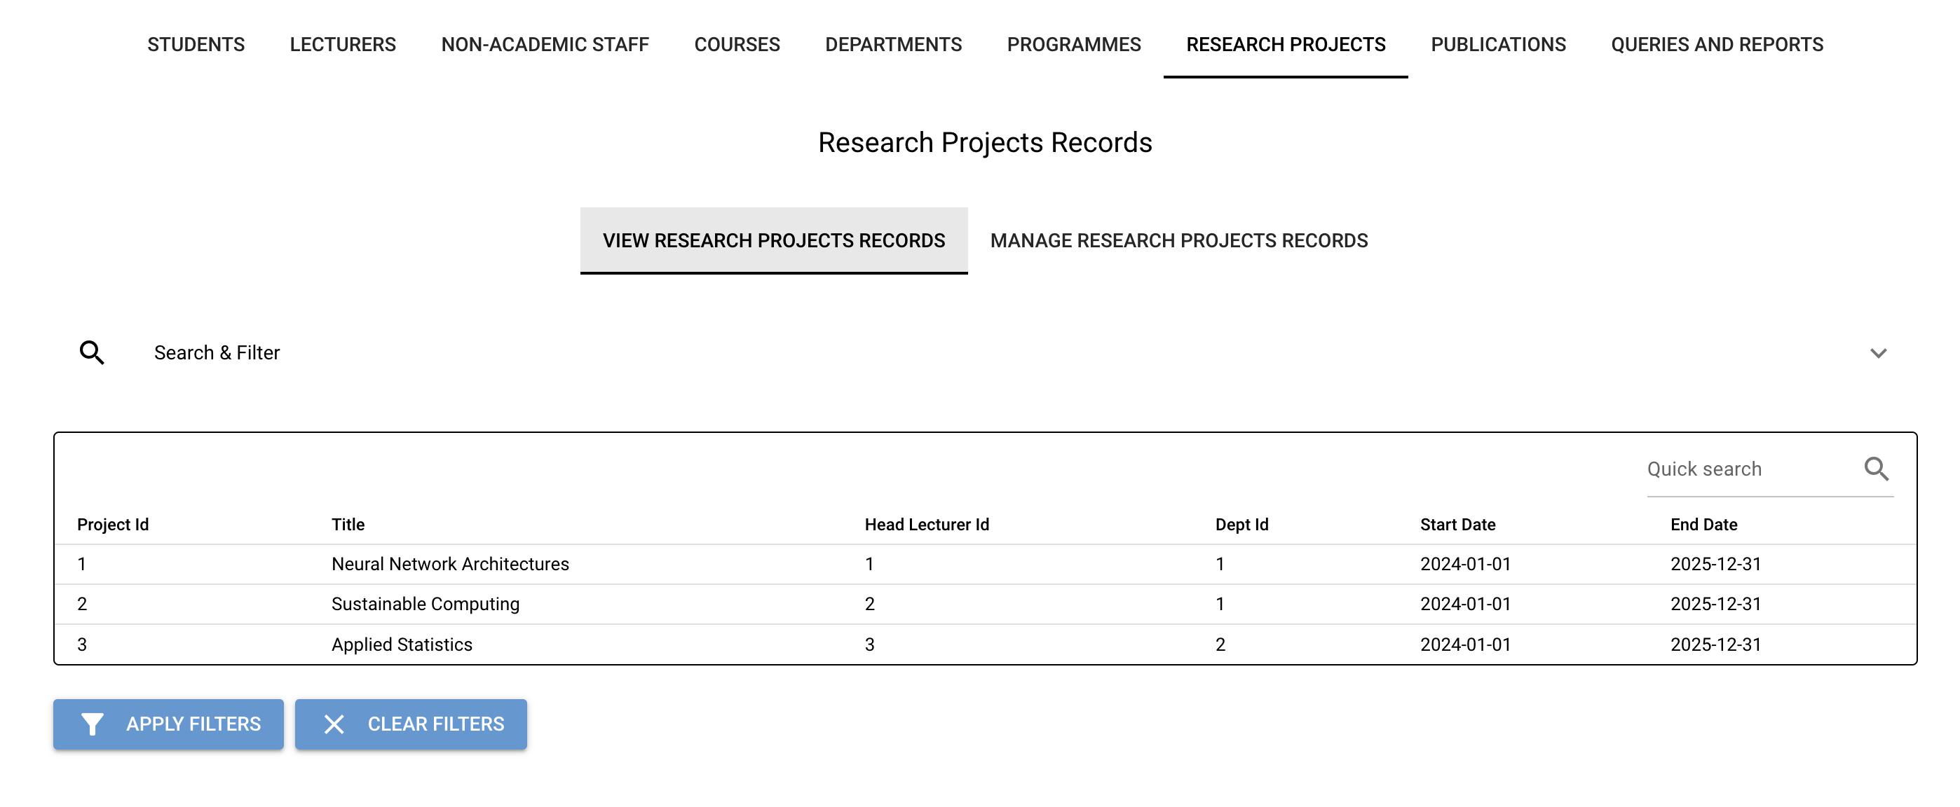

**Search & Filter:**

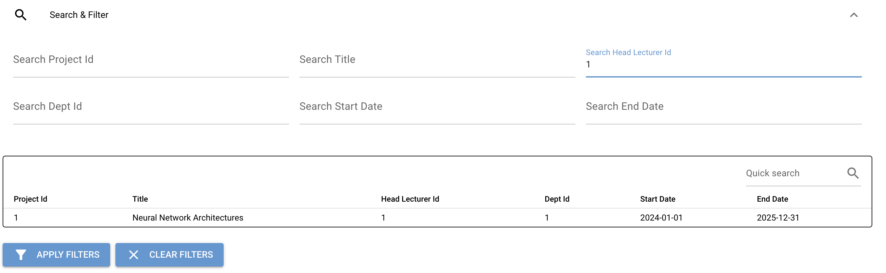

**Manage research projects Records:**



**Add research projects:**

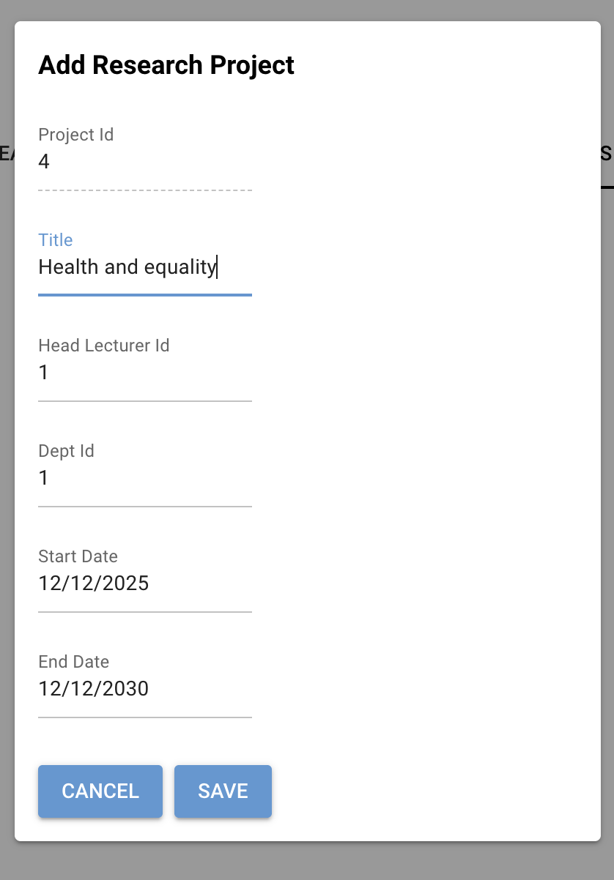

* + Head lecturer ID 1 is already being used so retried with 7

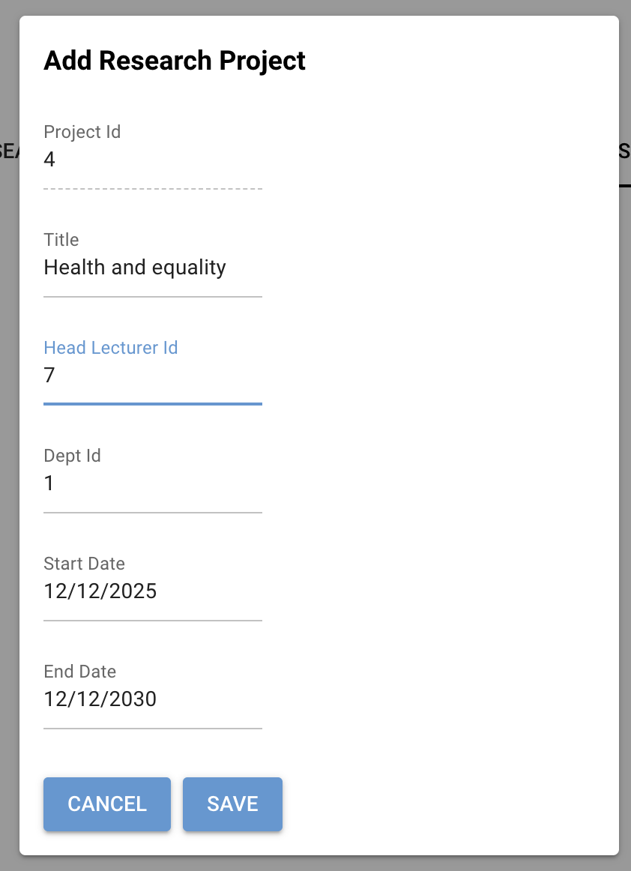

**Result:** Pass

**Edit research projects:**

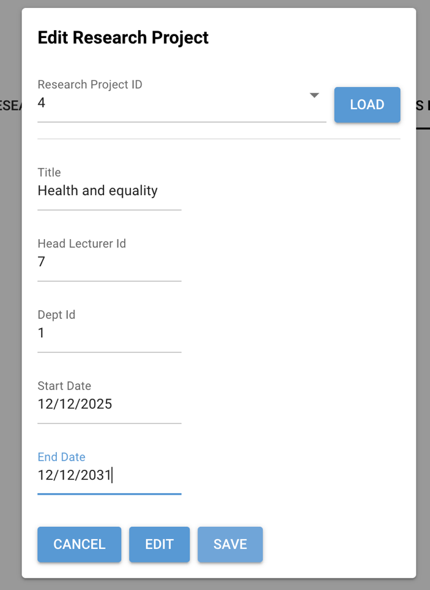

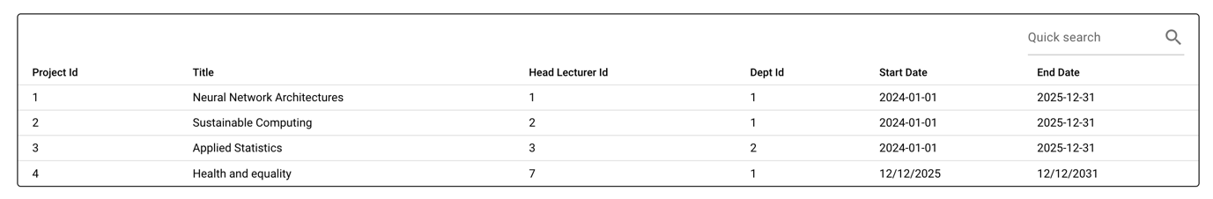

**Result:** Pass

**Delete research projects:**

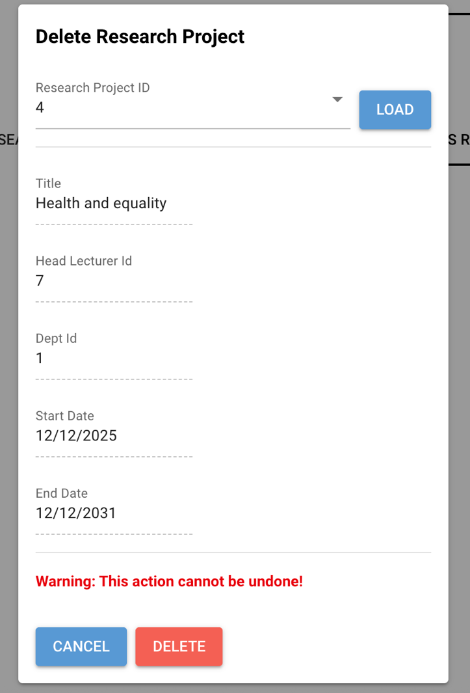

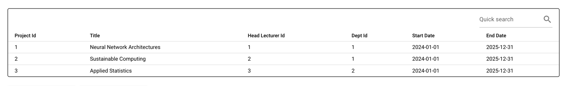

**Result:** Pass

**Publications – View publications records:**

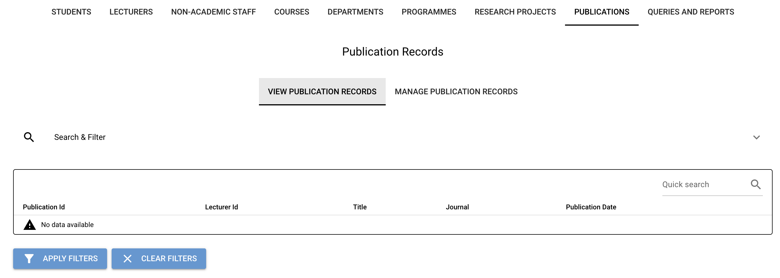

**Search & Filter:**

N/A

**Manage publications Records:**

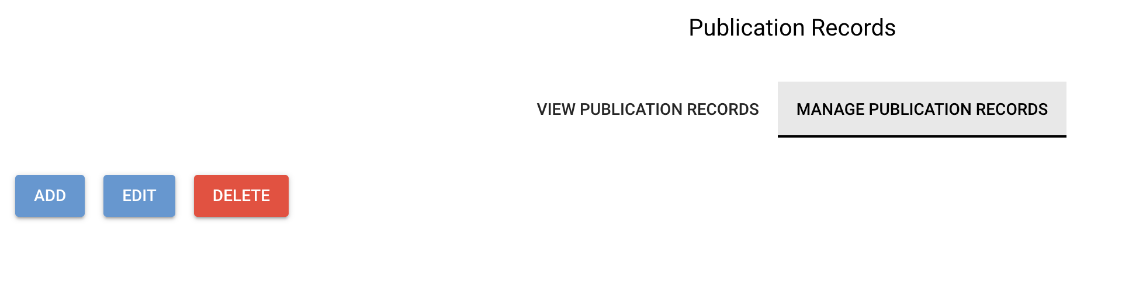

Publications tab shows CRUD buttons but Publications entity has no repo; add/edit/delete not supported.

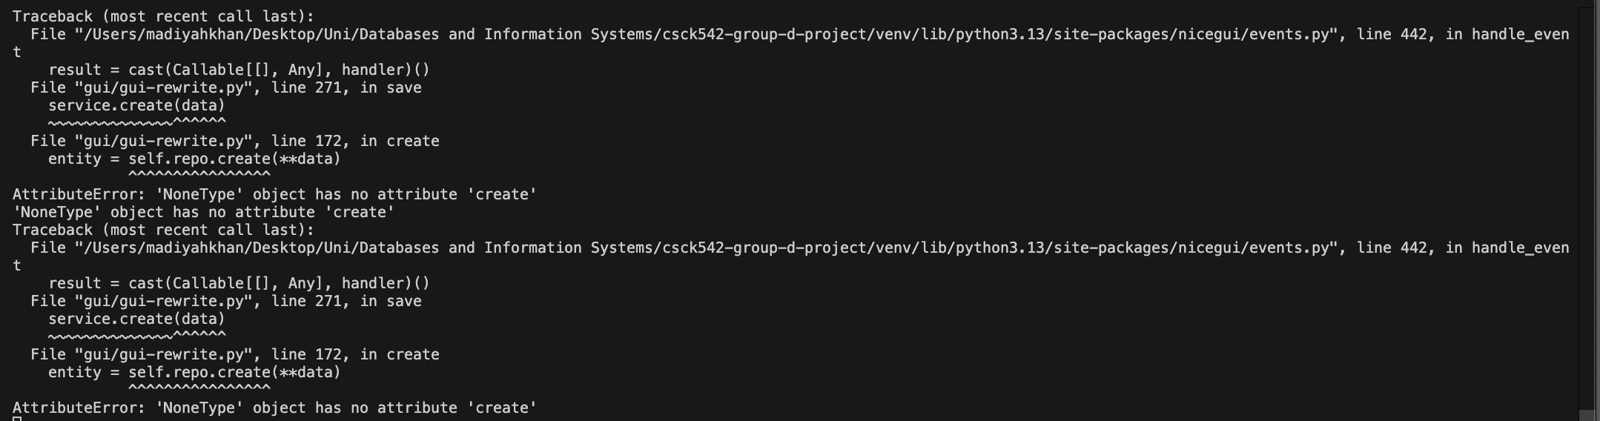

**Observed Behaviour:**

Attempting to add a Publication via the GUI results in no record being created.

**Expected Behaviour:**

Publication should be persisted and associated with a Lecturer.

**Actual Behaviour:**

Backend error occurs due to missing repository wiring (NoneType error).

**Conclusion:**

Publication creation is partially implemented and not fully integrated into the service layer.

**Queries and Reports:**

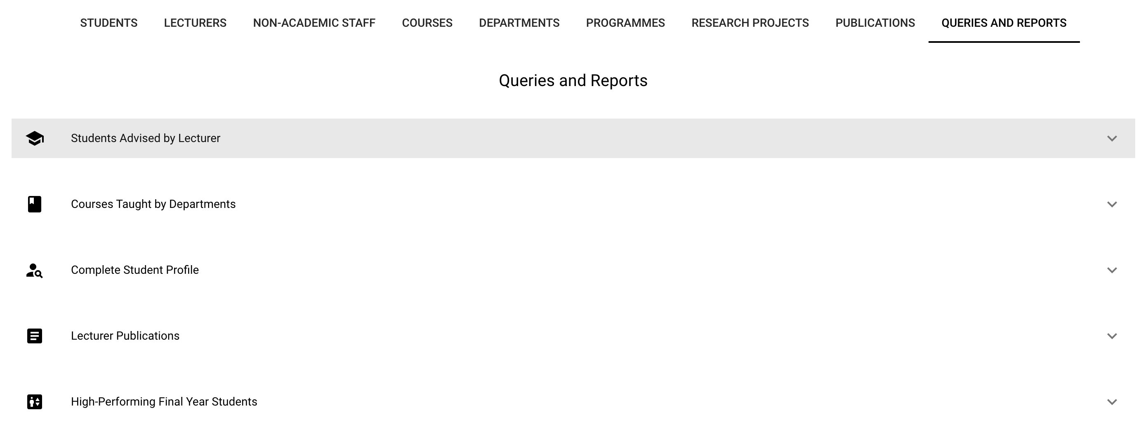

**Result:** Pass

**Queries and Reports – Students advised by lecturer:**

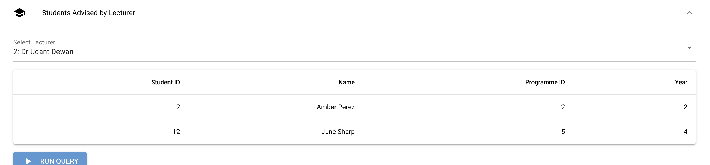

**Result:** Pass (with known limitation on foreign key validation)

**Queries and Reports – Courses offered by departments:**

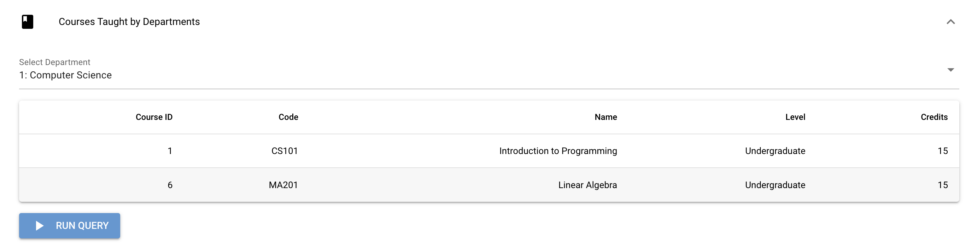

**Queries and Reports – Complete student profile:**

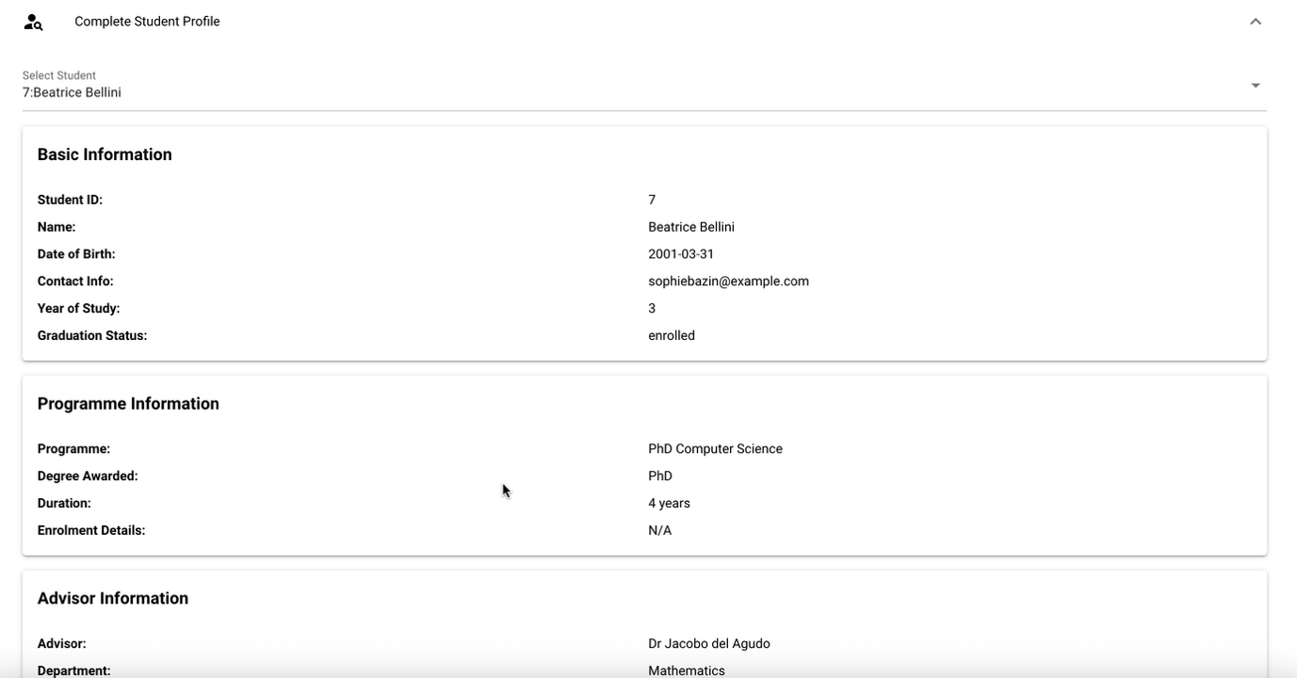

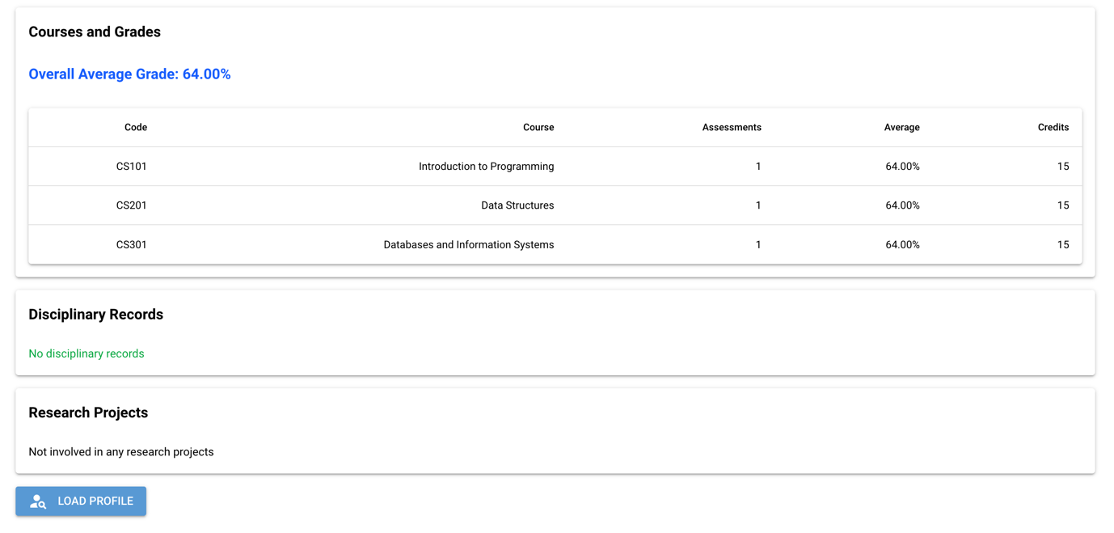

**Result:** Pass

**Queries and Reports – Lecturer publications:**

Lecturer Publications query returns 0 results because no publication data exists in the seeded dataset.

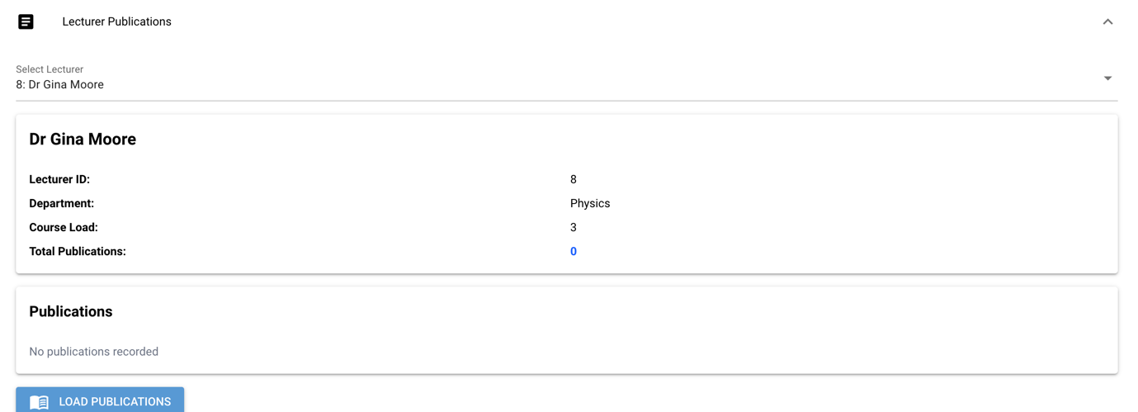

**Result:** Pass

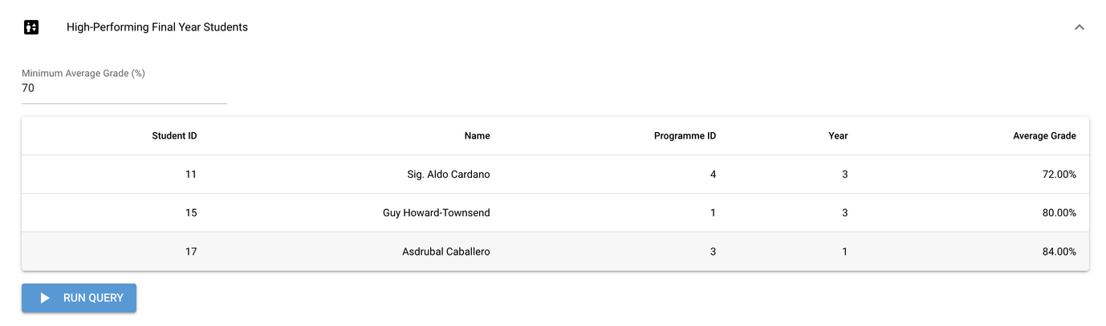

**Result:** Pass